**Deploying Web Application Deployment through Azure**

**Objective**

To familiarize participants with **cloud infrastructure, containerization, and automation**. By deploying a web app using HTML and CSS on Azure Free Tier, participants will learn to set up resources like **VMs**, **AKS**, and **ACR**, **containerize** applications with **Docker**, and automate deployment with **Azure DevOps** pipelines. The goal is to provide hands-on experience in **DevOps practices, CI/CD workflows**, and **resource optimization** within free-tier limits.

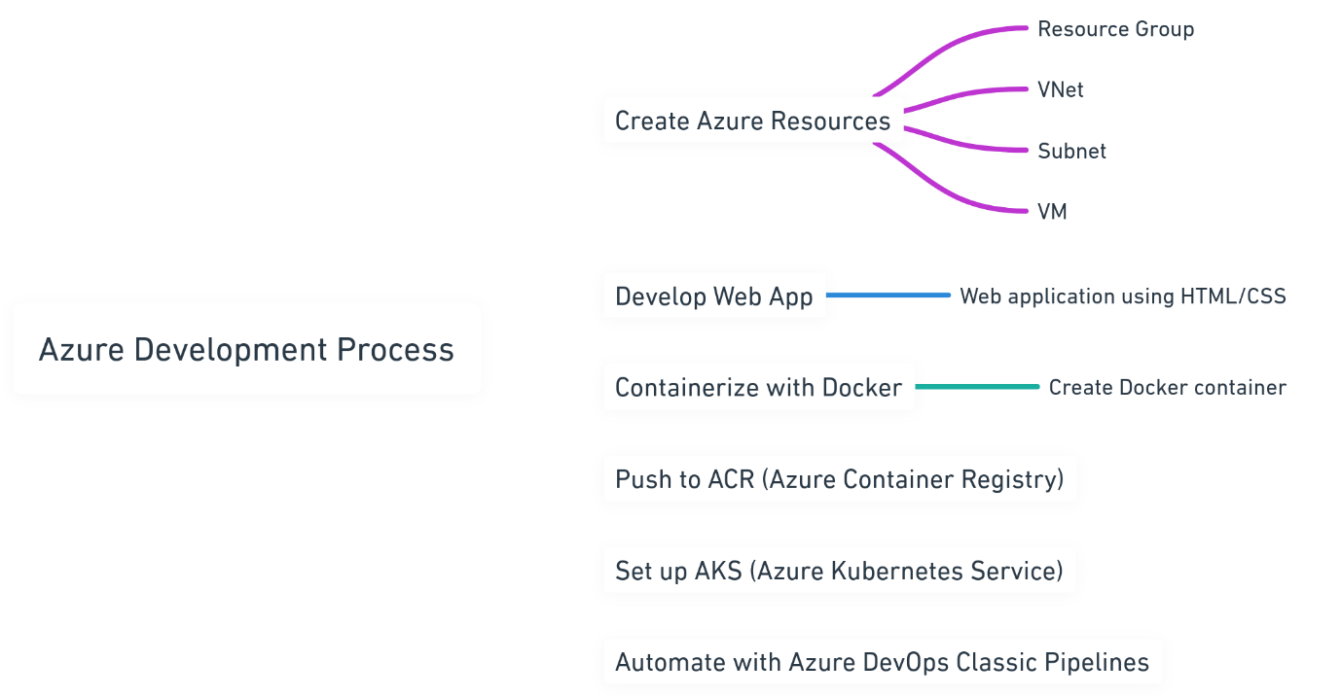

**Requirements and Tools Needed**

* **Azure Free Tier Account**: For accessing Azure services.
* **Azure CLI**: To manage Azure resources.
* **Docker**: For containerizing the web application.
* **Kubectl**: To interact with Kubernetes clusters.
* **Git**: For version control.
* **Visual Studio Code (optional)**: For code editing.
* **Azure DevOps Account**: For setting up CI/CD pipelines.
* **Web Development Knowledge**: Basic understanding of HTML, CSS, Docker, Kubernetes, ACR, and Kubernetes clusters.
* **Azure Container Registry (ACR)**: Azure's service for storing and managing Docker container images.

• **Kubernetes**: A system for automating the management of containerized applications.

* **Kubernetes Cluster**: A set of nodes managed by Kubernetes to run containerized apps.

**Manual Deployment Using Bash Script**

This document provides steps to manually deploy a web application using a Bash script. The steps include creating Azure resources, containerizing the application with Docker, pushing the Docker image to Azure Container Registry (ACR), and deploying it on Azure Kubernetes Service (AKS).

**Create a Resource Group**

az group create --name CDPGenCTechServices-2355454-RG --location centralus

**Create a Virtual Network and Subnet**

az network vnet create --resource-group CDPGenCTechServices-2355454-RG --name MyVnet --address-prefix 10.0.0.0/16 --subnet-name MySubnet --subnet-prefix 10.0.0.0/24

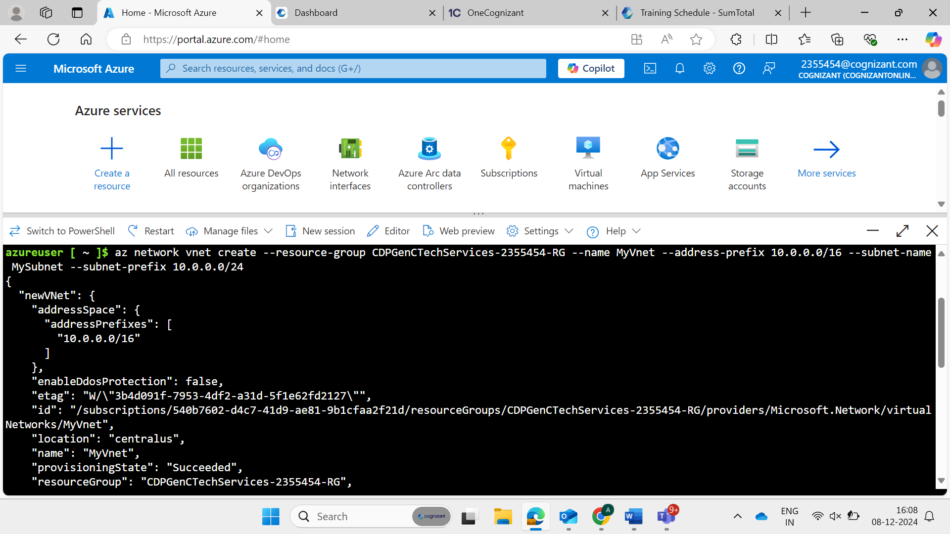

**Create a network security group**

az network nsg create --resource-group CDPGenCTechServices-2355454-RG --name MyNSG

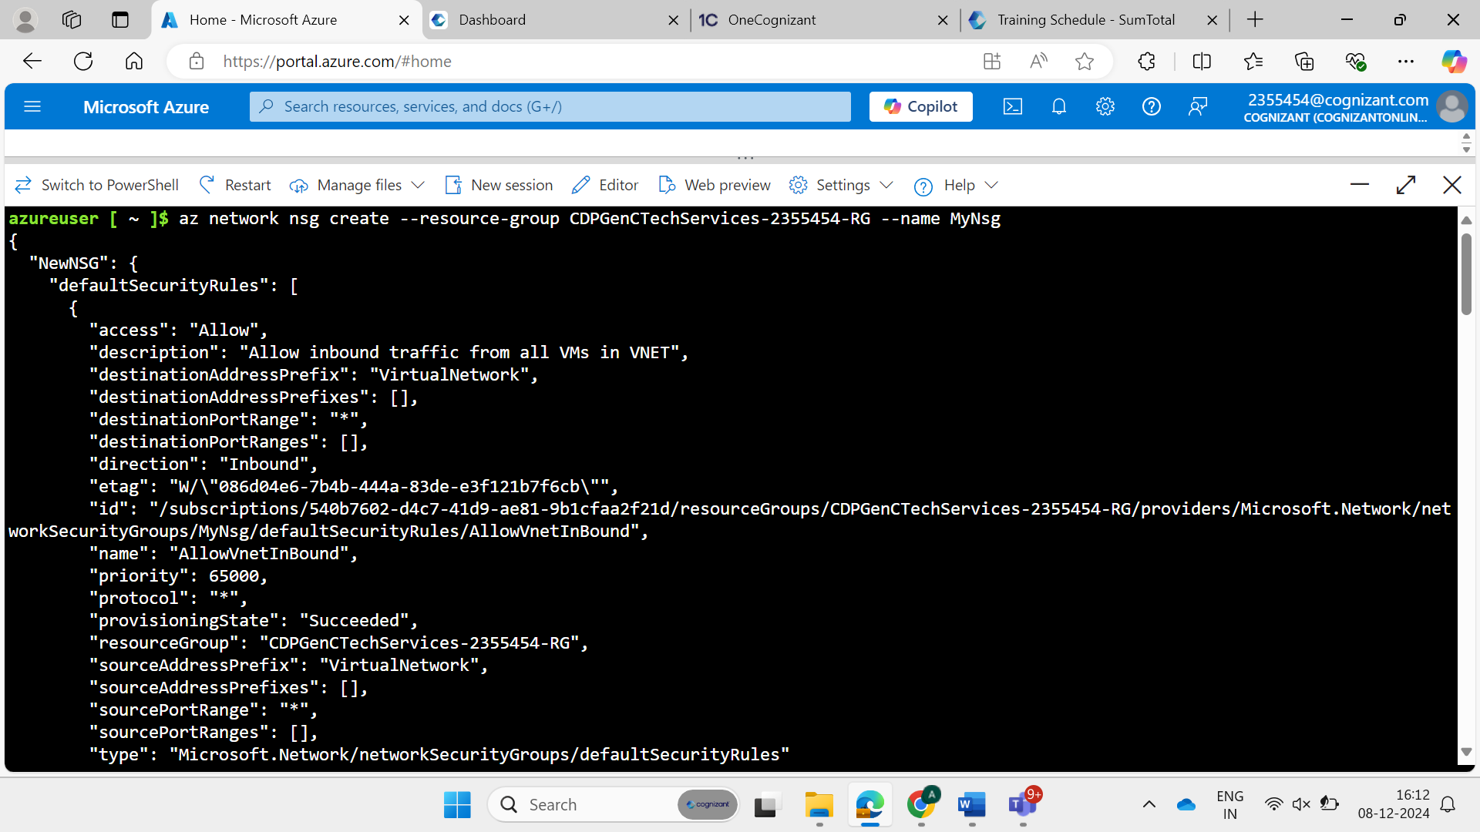

**Create NSG Rules to Allow Ports 22 and 80**

az network nsg rule create --resource-group CDPGenCTechServices-2355454-RG --nsg-name MyNSG --name Allow-SSH --protocol tcp --priority 1000 --destination-port-range 22 --access allow

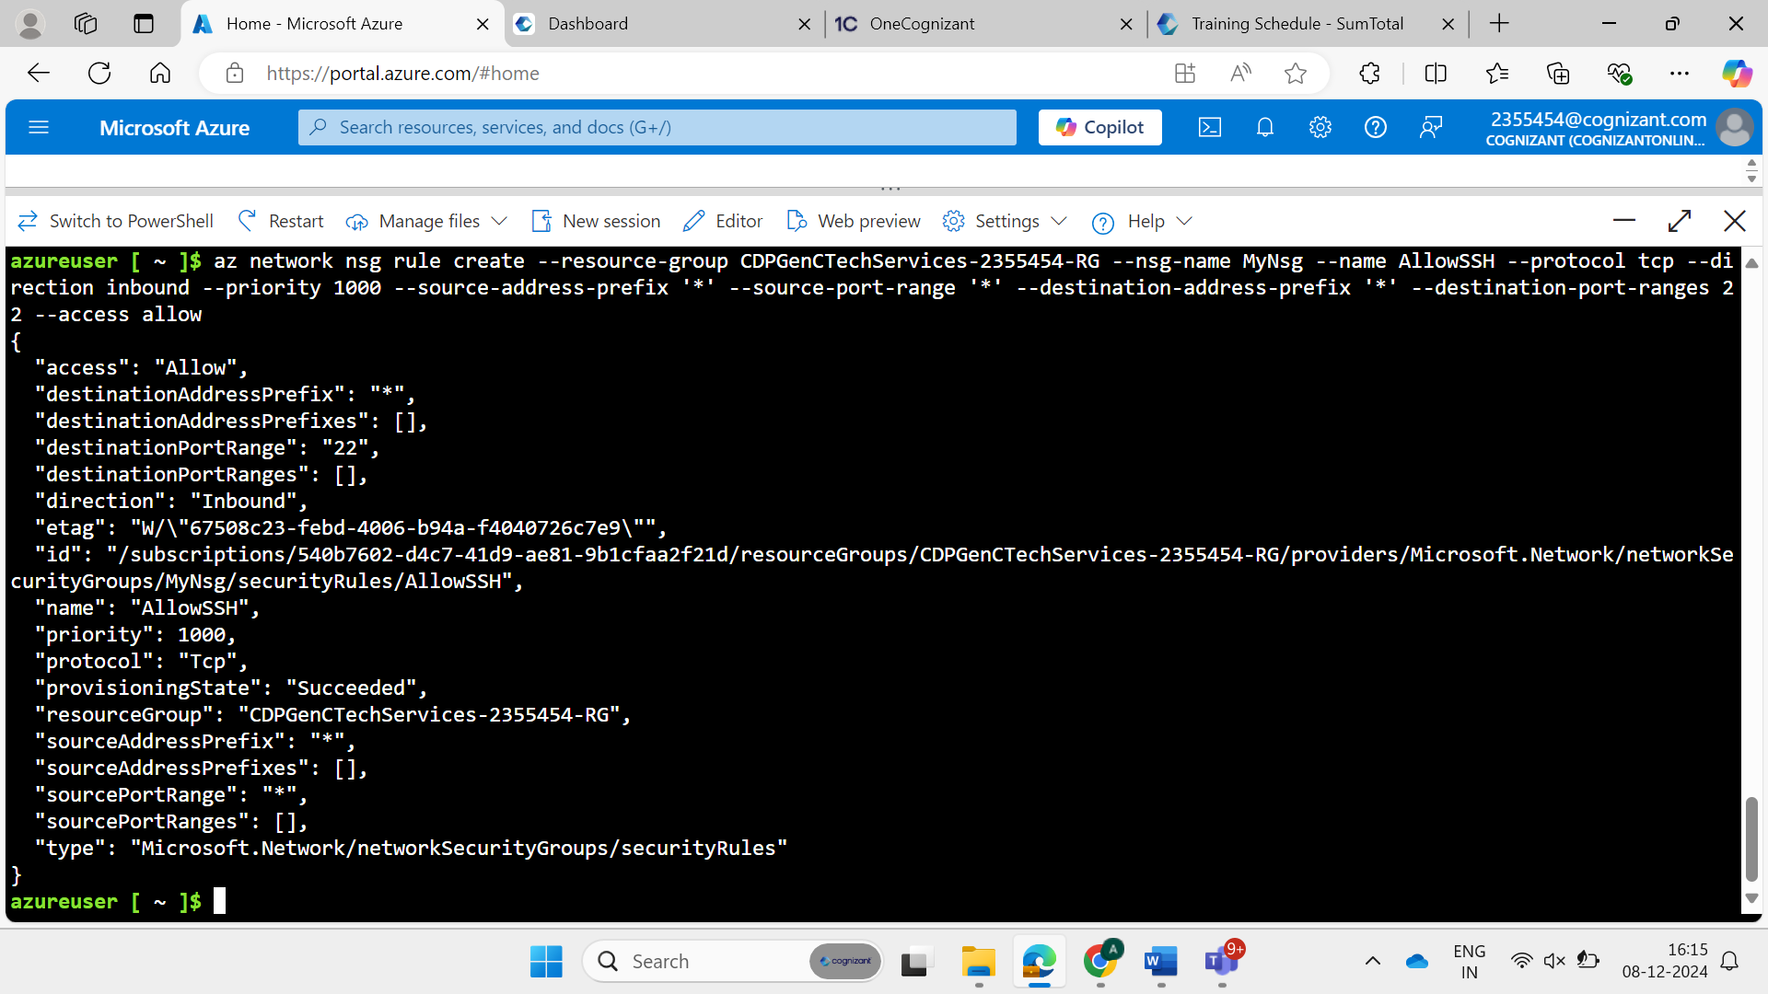

az network nsg rule create --resource-group CDPGenCTechServices-2355454-RG --nsg-name MyNSG --name Allow-HTTP --protocol tcp --priority 2000 --destination-port-range 80 --access allow

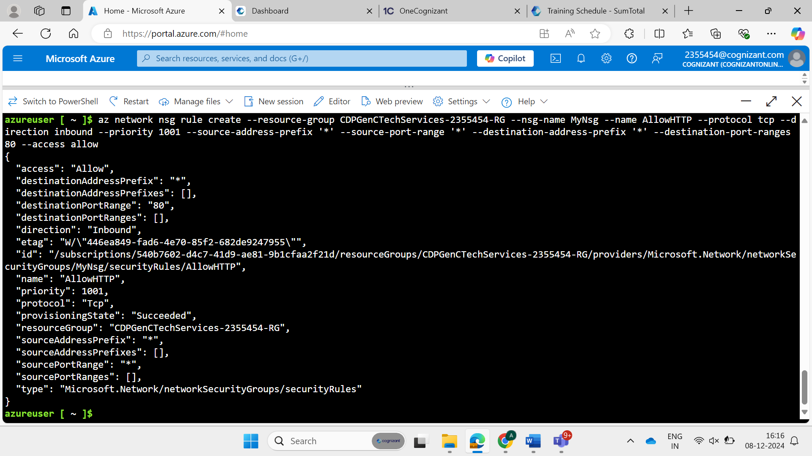

**Create a Public IP Address**

az network public-ip create --resource-group CDPGenCTechServices-2355454-RG --name MyPublicIP

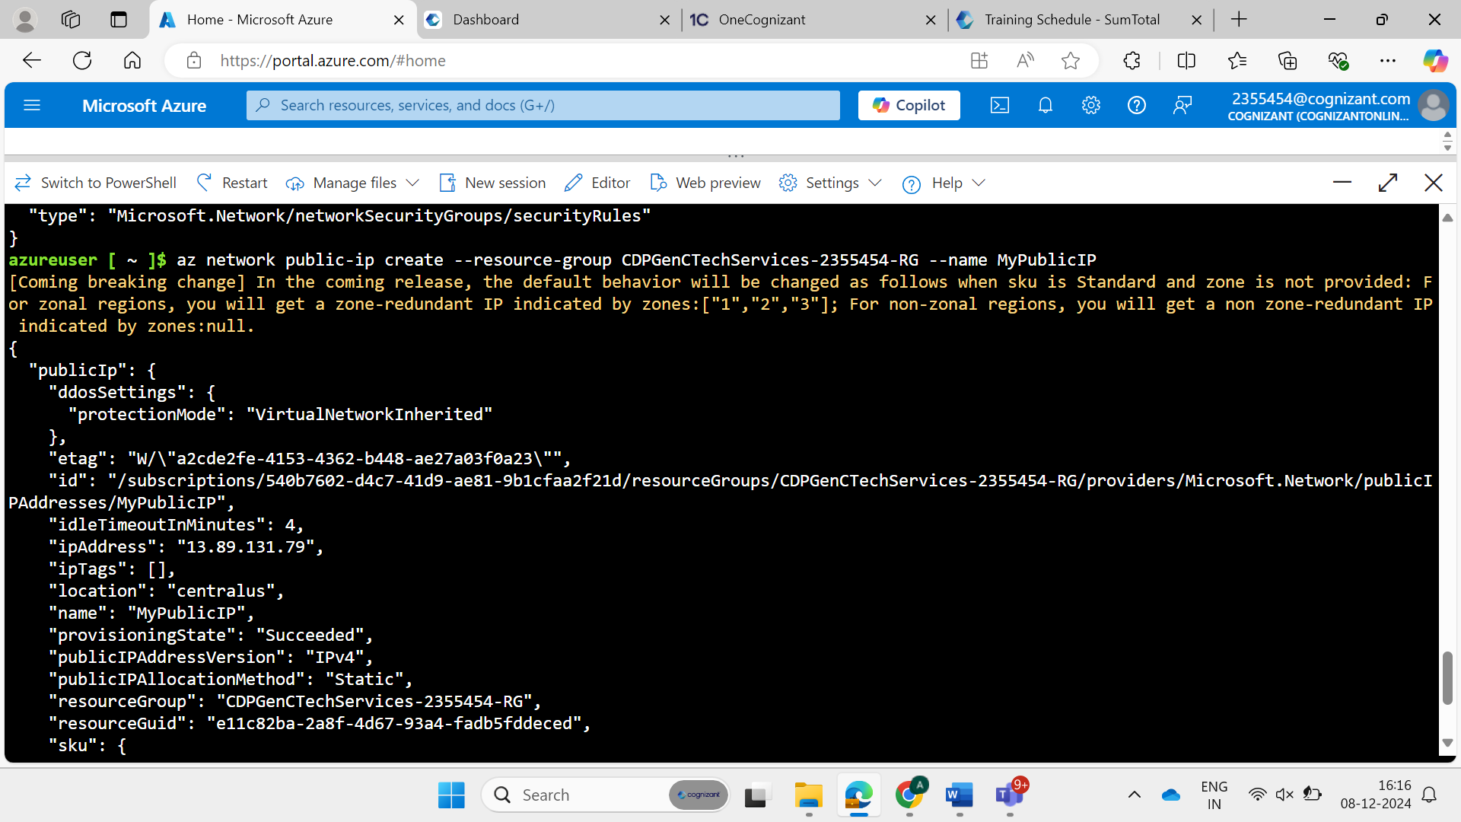

**Create Network Interface Card (NIC) and Associate it with the Public IP Address and NSG**

az network nic create --resource-group CDPGenCTechServices-2355454-RG --name MyNIC --vnet-name MyVnet --subnet MySubnet --network-security-group MyNSG --public-ip-address MyPublicIP

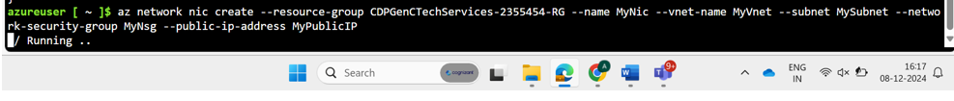

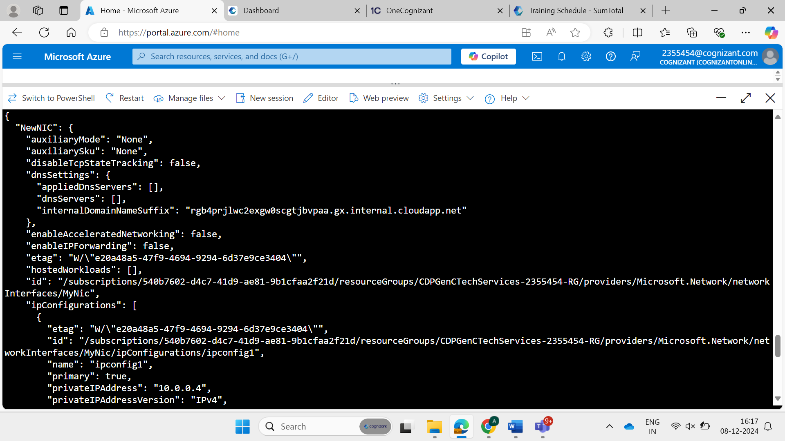

**Create ACR**

az acr create --resource-group CDPGenCTechServices-2355454-RG --name anupamregistery --sku Basic

**Create VM**

az vm create --resource-group CDPGenCTechServices-2355454-RG --name anupam --image UbuntuLTS2204 --size Standard_B1s --admin-username anupam --admin-password Anupams@2312 --nics MyNic --location CentralUS --tags Project=DevEnvironment Purpose="Development environment to host tools and test applications"

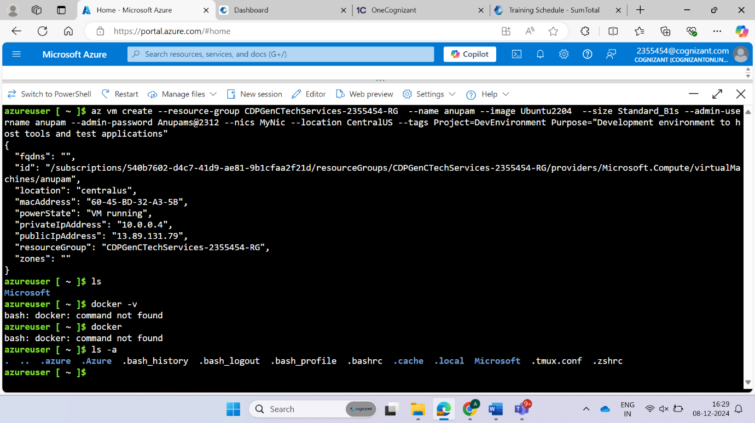

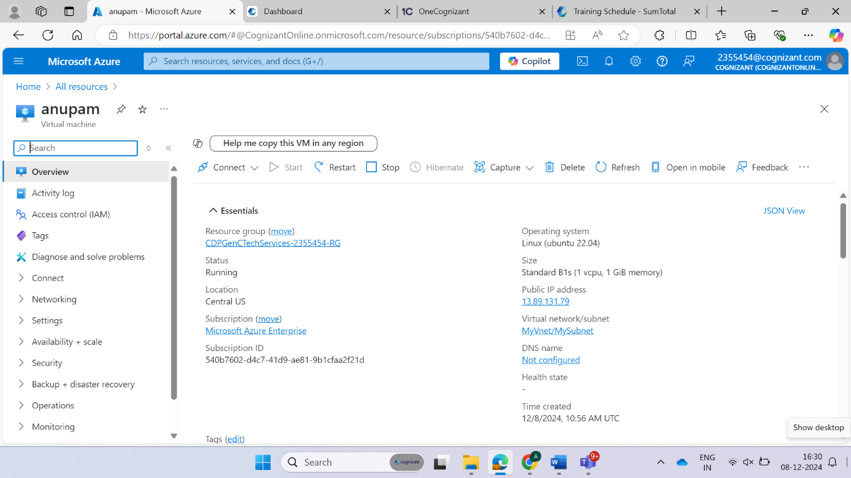

**Docker Installation on VM**

Two ways to install docker-

1. sudo apt-get update

sudo apt-get install docker.io

1. sudo snap install docker

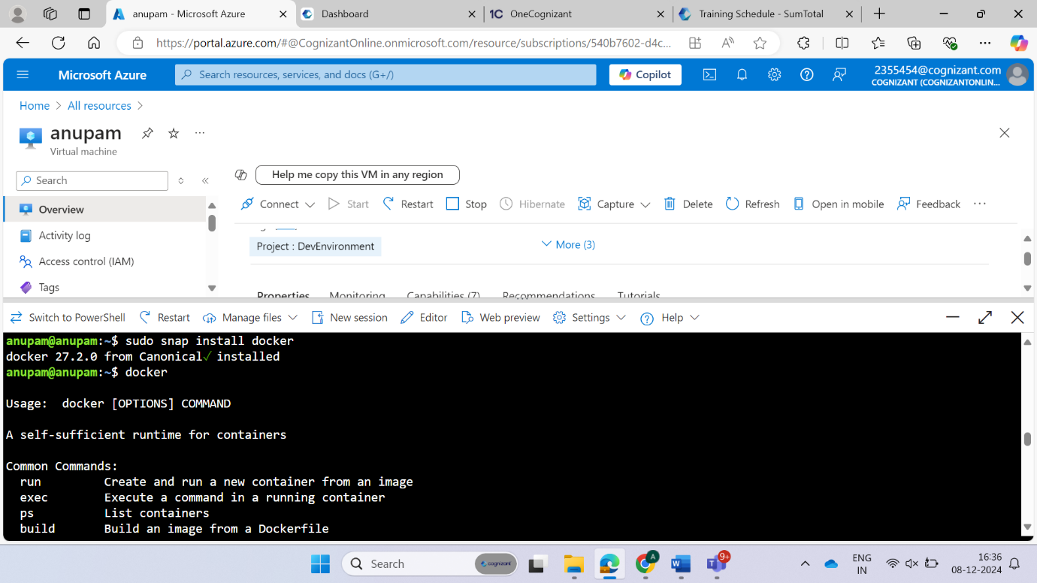

**WEB APPLICATION**

Create index.html file and dockerfile

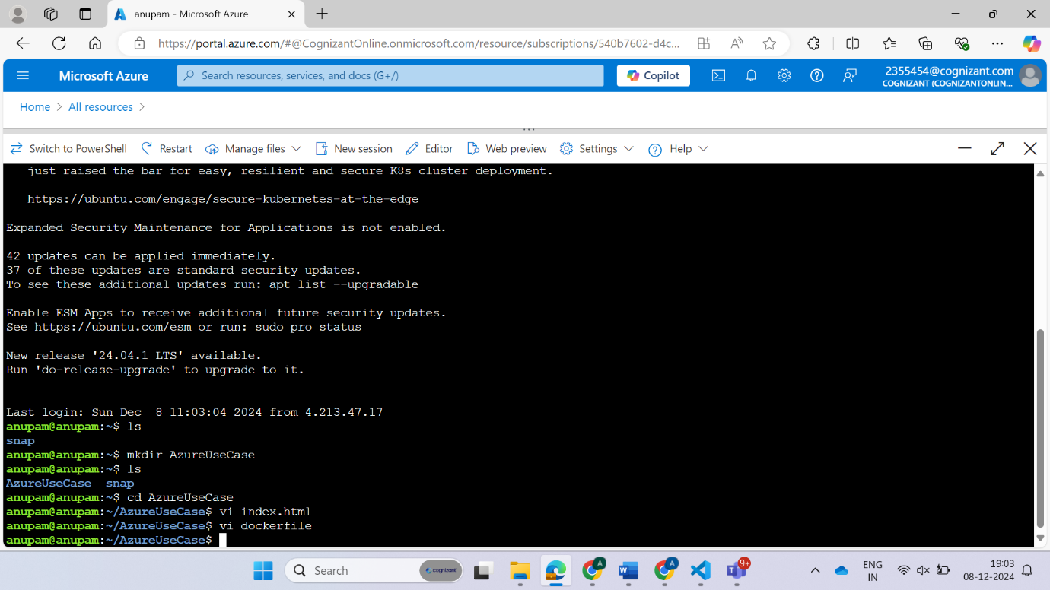

**index.html**

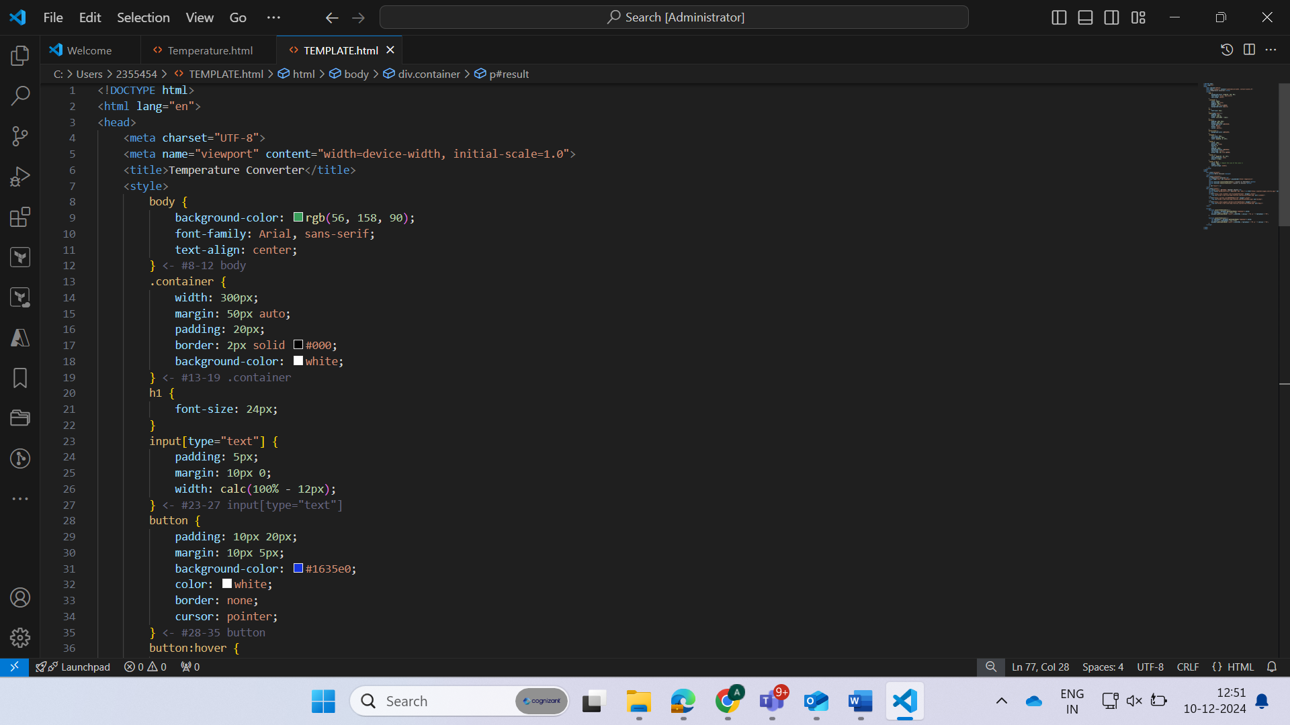

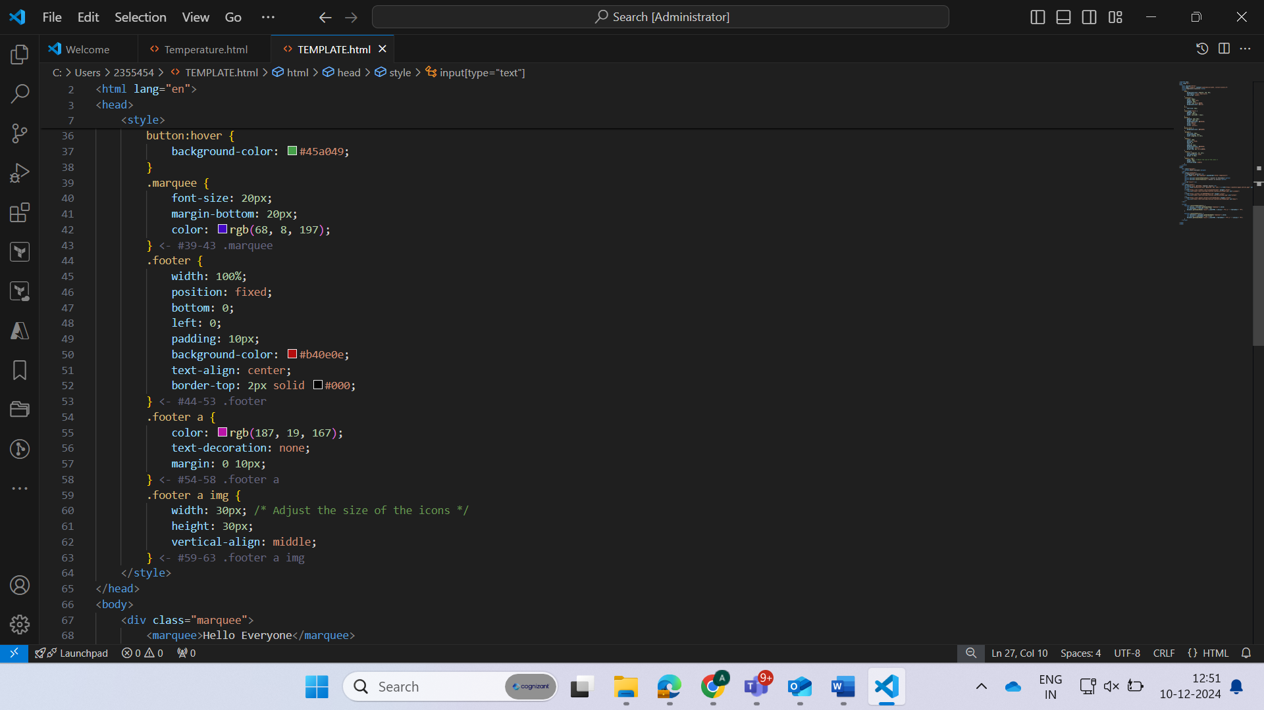

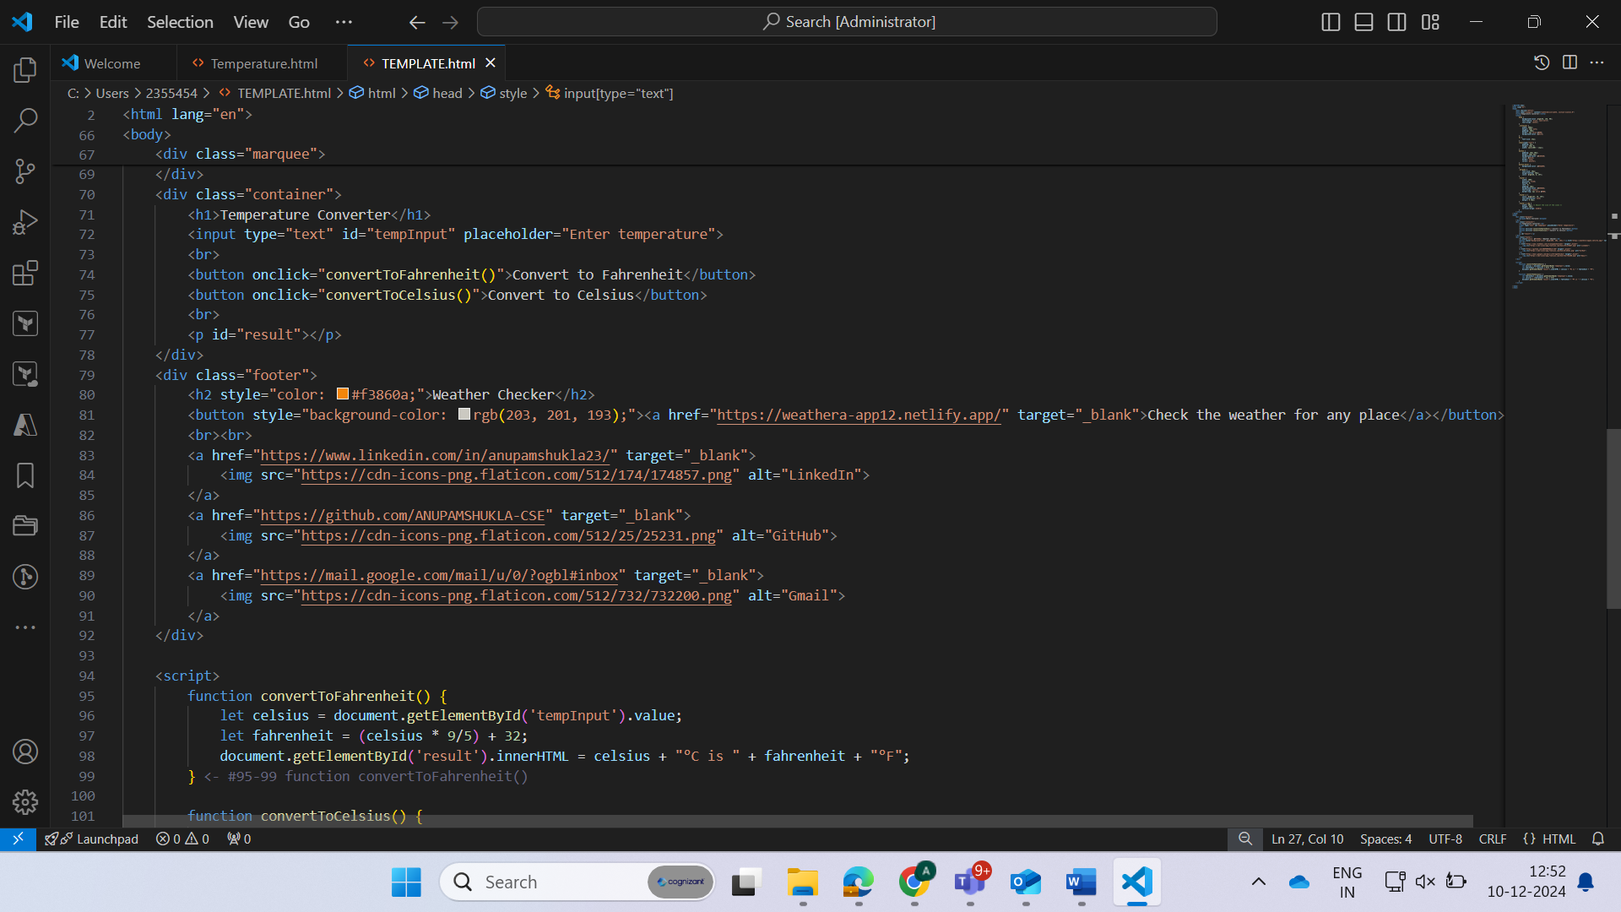

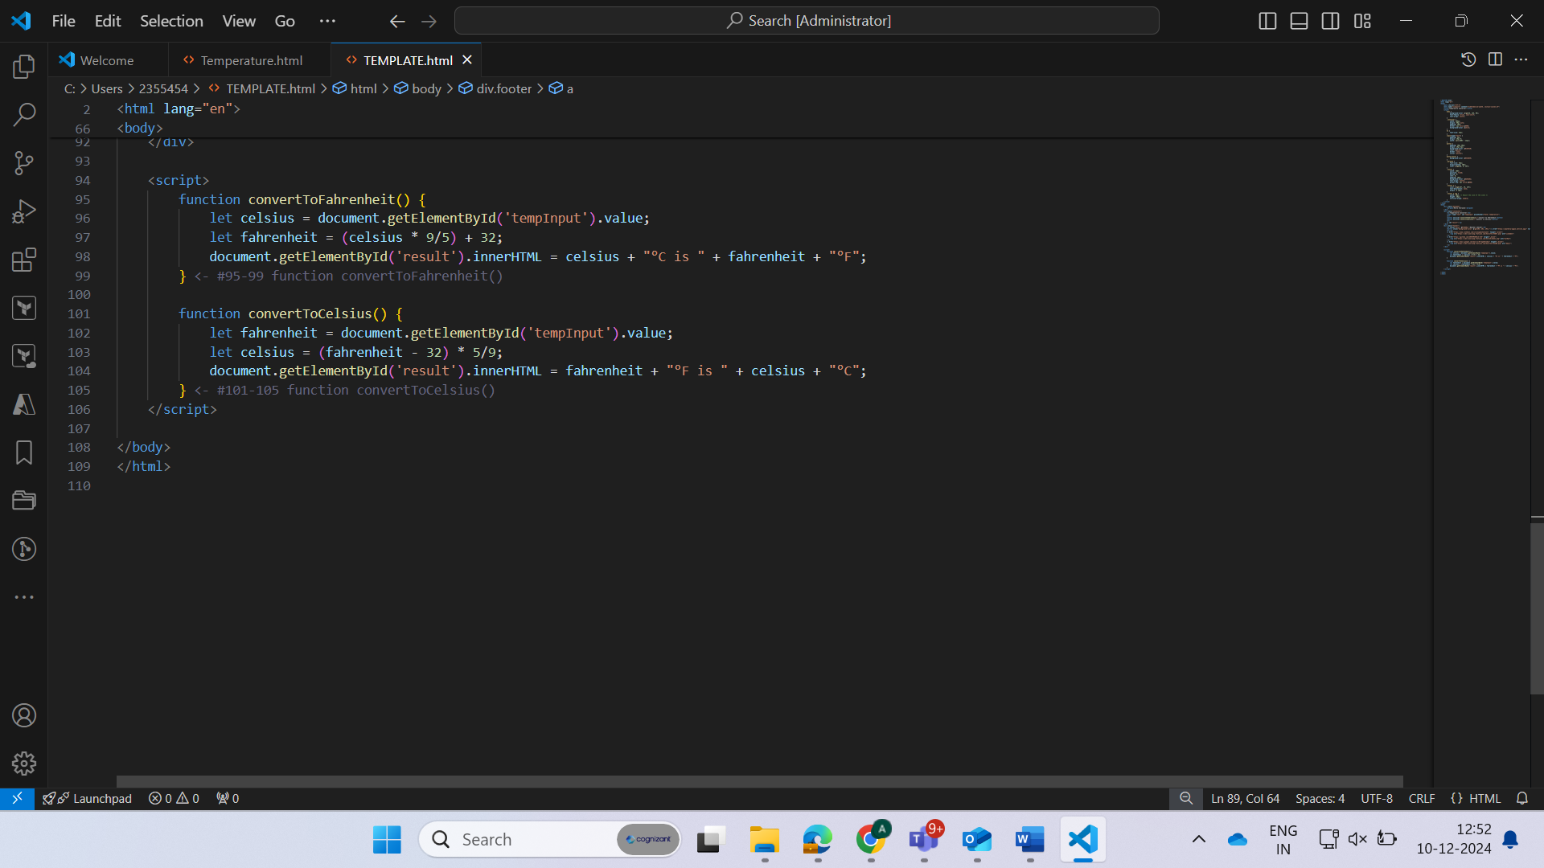

**Code**

<!DOCTYPE html>

<html lang="en">

<head>

    <meta charset="UTF-8">

    <meta name="viewport" content="width=device-width, initial-scale=1.0">

    <title>Temperature Converter</title>

    <style>

        body {

            background-color: rgb(56, 158, 90);

            font-family: Arial, sans-serif;

            text-align: center;

        }

        .container {

            width: 300px;

            margin: 50px auto;

            padding: 20px;

            border: 2px solid #000;

            background-color: white;

        }

        h1 {

            font-size: 24px;

        }

        input[type="text"] {

            padding: 5px;

            margin: 10px 0;

            width: calc(100% - 12px);

        }

        button {

            padding: 10px 20px;

            margin: 10px 5px;

            background-color: #1635e0;

            color: white;

            border: none;

            cursor: pointer;

        }

        button:hover {

            background-color: #45a049;

        }

        .marquee {

            font-size: 20px;

            margin-bottom: 20px;

            color: rgb(68, 8, 197);

        }

        .footer {

            width: 100%;

            position: fixed;

            bottom: 0;

            left: 0;

            padding: 10px;

            background-color: #b40e0e;

            text-align: center;

            border-top: 2px solid #000;

        }

        .footer a {

            color: rgb(187, 19, 167);

            text-decoration: none;

            margin: 0 10px;

        }

        .footer a img {

            width: 30px; /* Adjust the size of the icons */

            height: 30px;

            vertical-align: middle;

        }

    </style>

</head>

<body>

    <div class="marquee">

        <marquee>Hello Everyone</marquee>

    </div>

    <div class="container">

        <h1>Temperature Converter</h1>

        <input type="text" id="tempInput" placeholder="Enter temperature">

        <br>

        <button onclick="convertToFahrenheit()">Convert to Fahrenheit</button>

        <button onclick="convertToCelsius()">Convert to Celsius</button>

        <br>

        <p id="result"></p>

    </div>

    <div class="footer">

        <h2 style="color: #f3860a;">Weather Checker</h2>

        <button style="background-color: rgb(203, 201, 193);"><a href="https://weathera-app12.netlify.app/" target="_blank">Check the weather for any place</a></button>

        <br><br>

        <a href="https://www.linkedin.com/in/anupamshukla23/" target="_blank">

            <img src="https://cdn-icons-png.flaticon.com/512/174/174857.png" alt="LinkedIn">

        </a>

        <a href="https://github.com/ANUPAMSHUKLA-CSE" target="_blank">

            <img src="https://cdn-icons-png.flaticon.com/512/25/25231.png" alt="GitHub">

        </a>

        <a href="https://mail.google.com/mail/u/0/?ogbl#inbox" target="_blank">

            <img src="https://cdn-icons-png.flaticon.com/512/732/732200.png" alt="Gmail">

        </a>

    </div>

    <script>

        function convertToFahrenheit() {

            let celsius = document.getElementById('tempInput').value;

            let fahrenheit = (celsius * 9/5) + 32;

            document.getElementById('result').innerHTML = celsius + "°C is " + fahrenheit + "°F";

        }

        function convertToCelsius() {

            let fahrenheit = document.getElementById('tempInput').value;

            let celsius = (fahrenheit - 32) * 5/9;

            document.getElementById('result').innerHTML = fahrenheit + "°F is " + celsius + "°C";

        }

    </script>

</body>

</html>

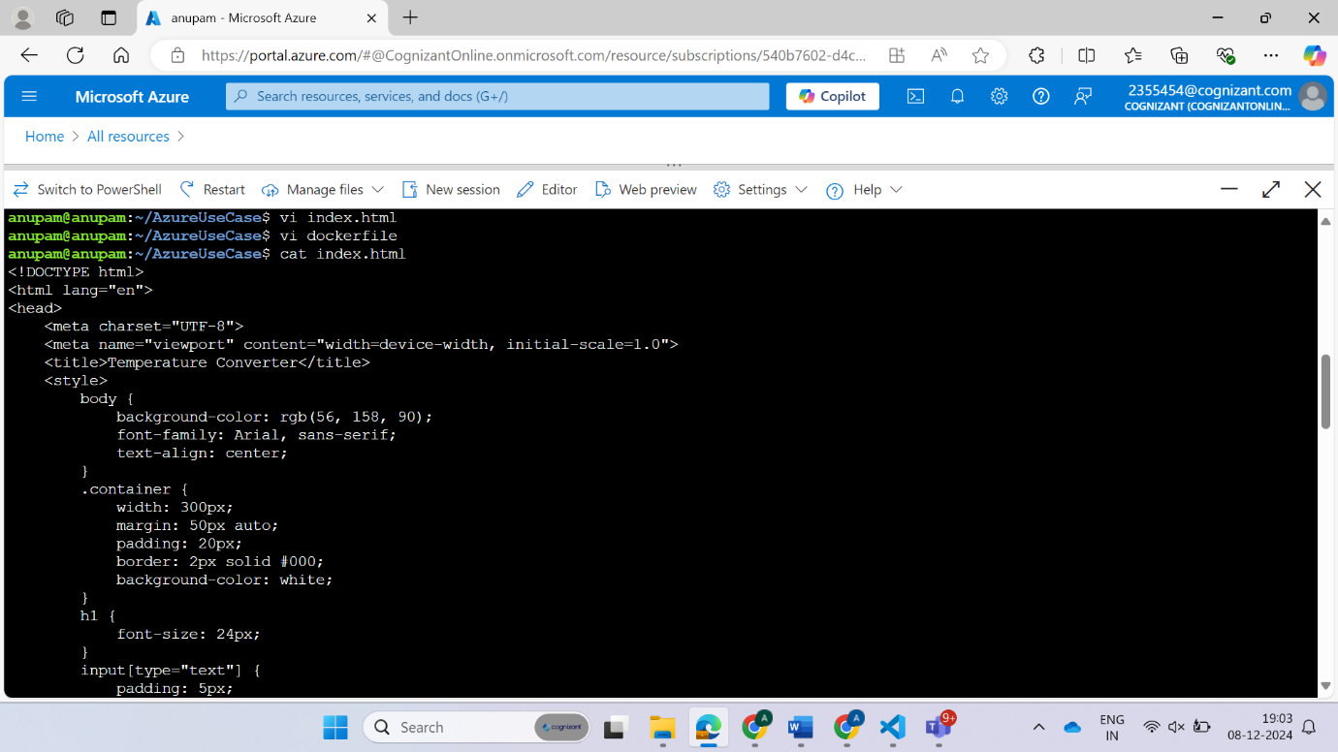

**dockerfile**

FROM nginx:latest

COPY index.html /usr/share/nginx/html/index.html

EXPOSE 80

CMD ["nginx", "-g", "daemon off;"]

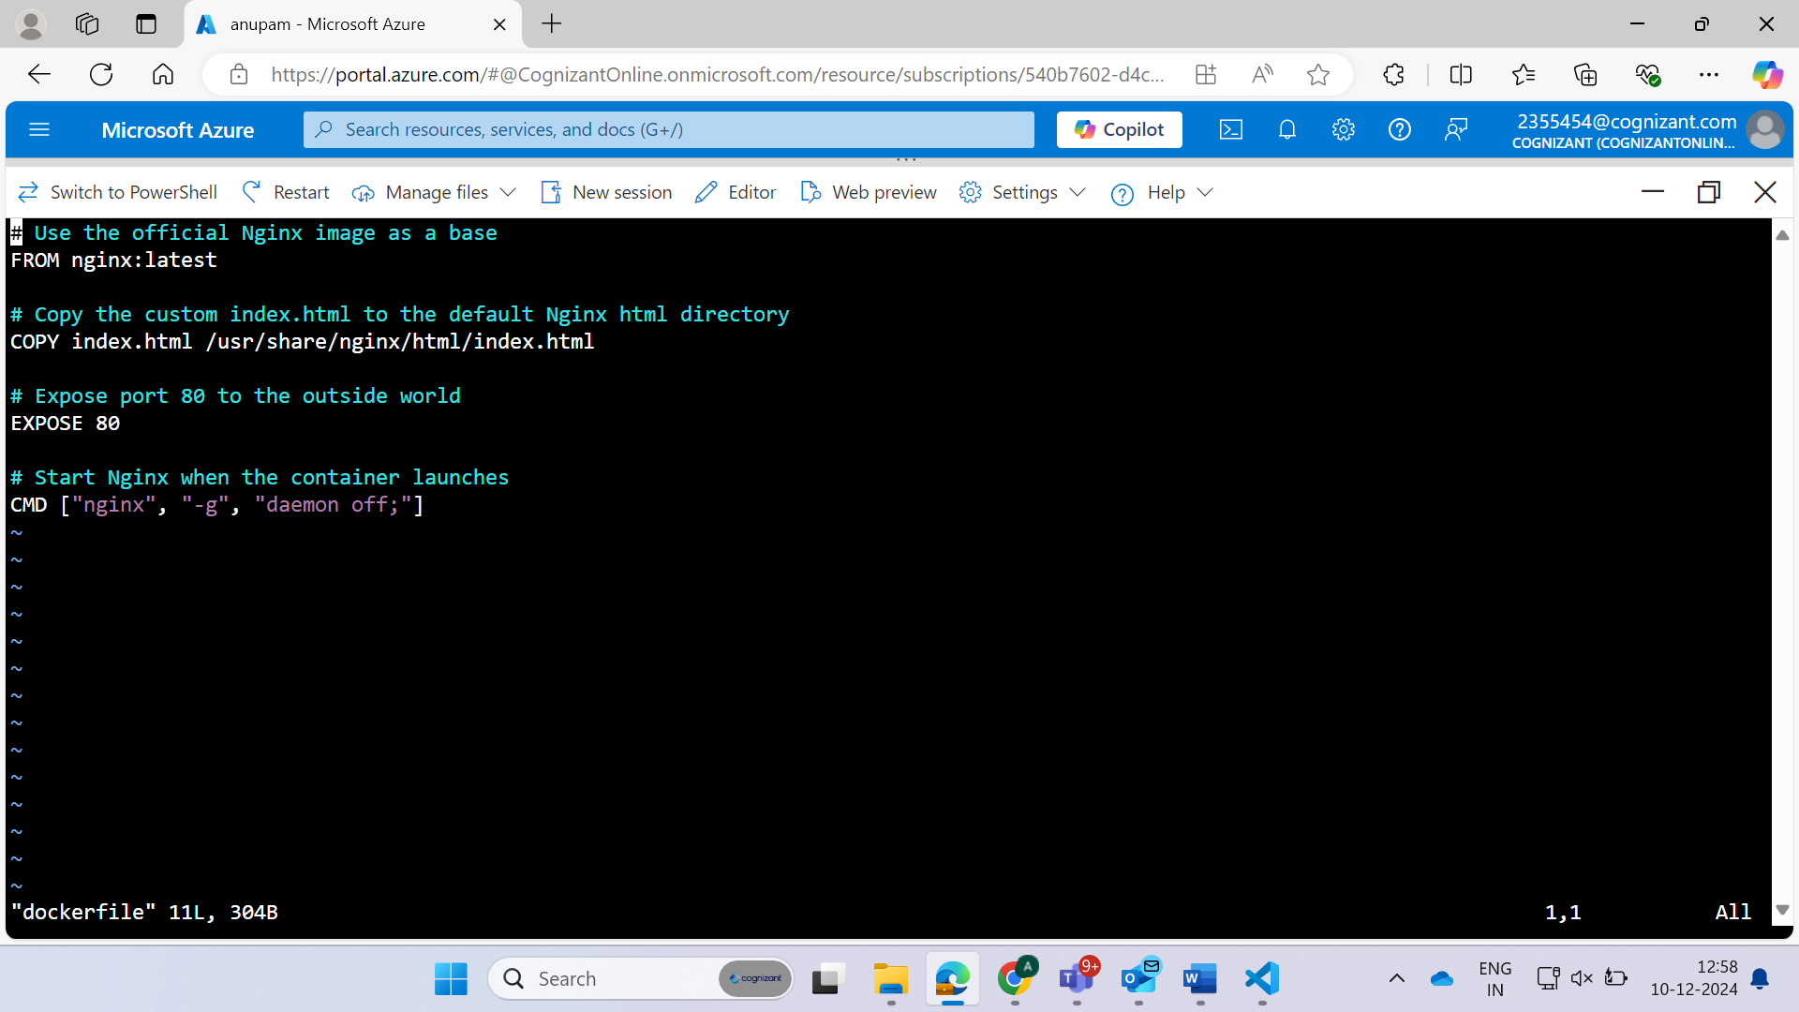

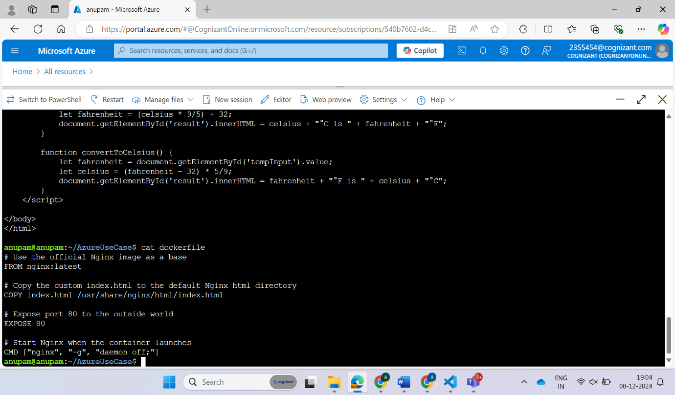

**Create a docker image**

docker build -t weather:01 .

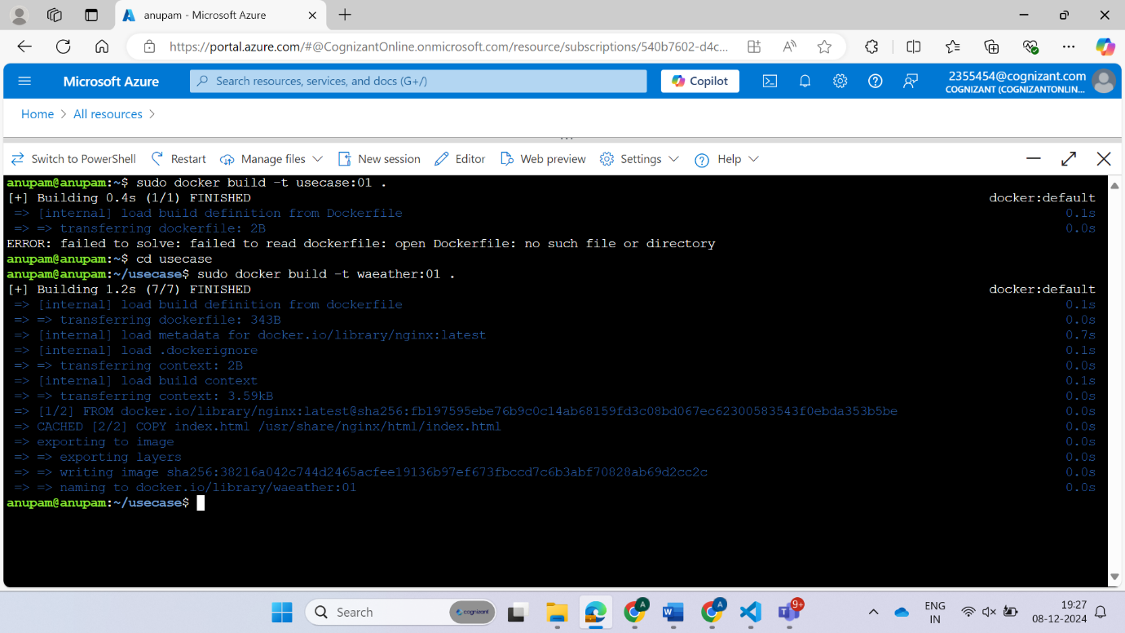

**Dockerhub**

Go to dockerhub and create the repository there and after that in that repository push the image which u have created.

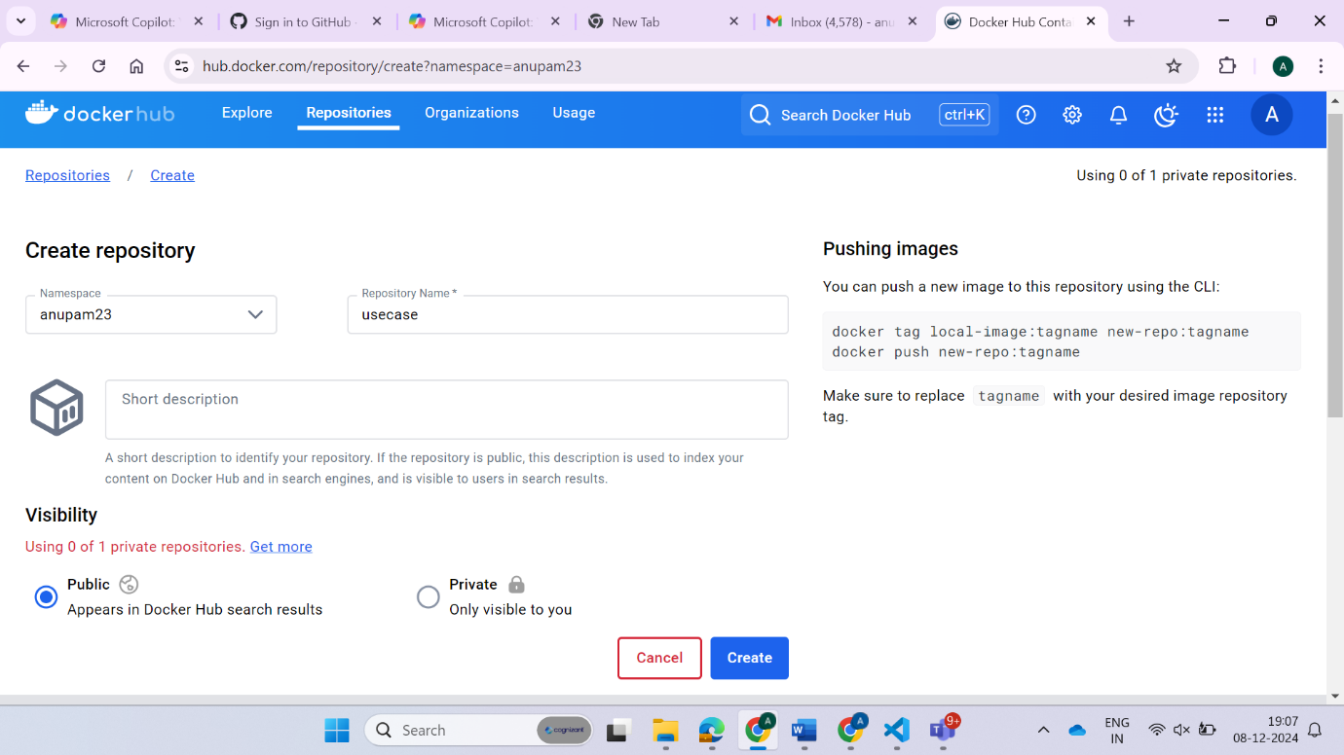

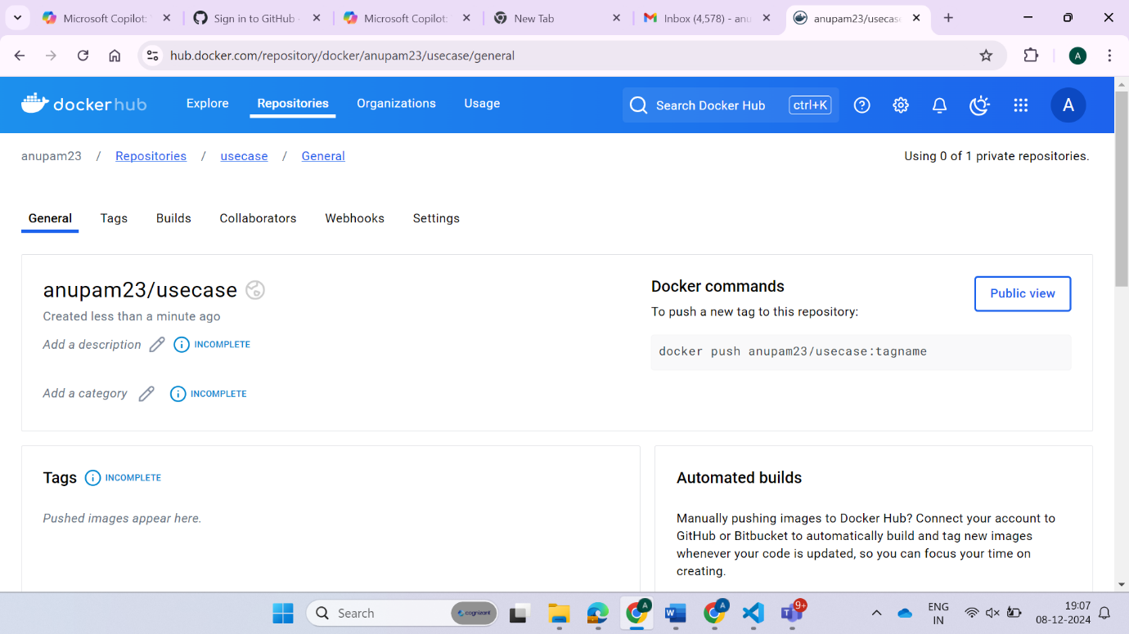

docker login -u anupam23

docker build -t anupam23/usecase:01 .

docker push anupam23/usecase:01

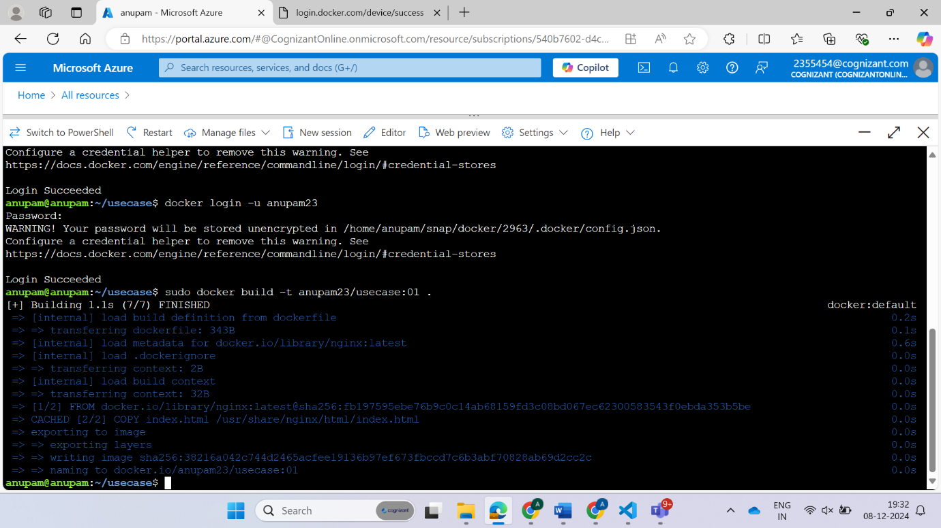

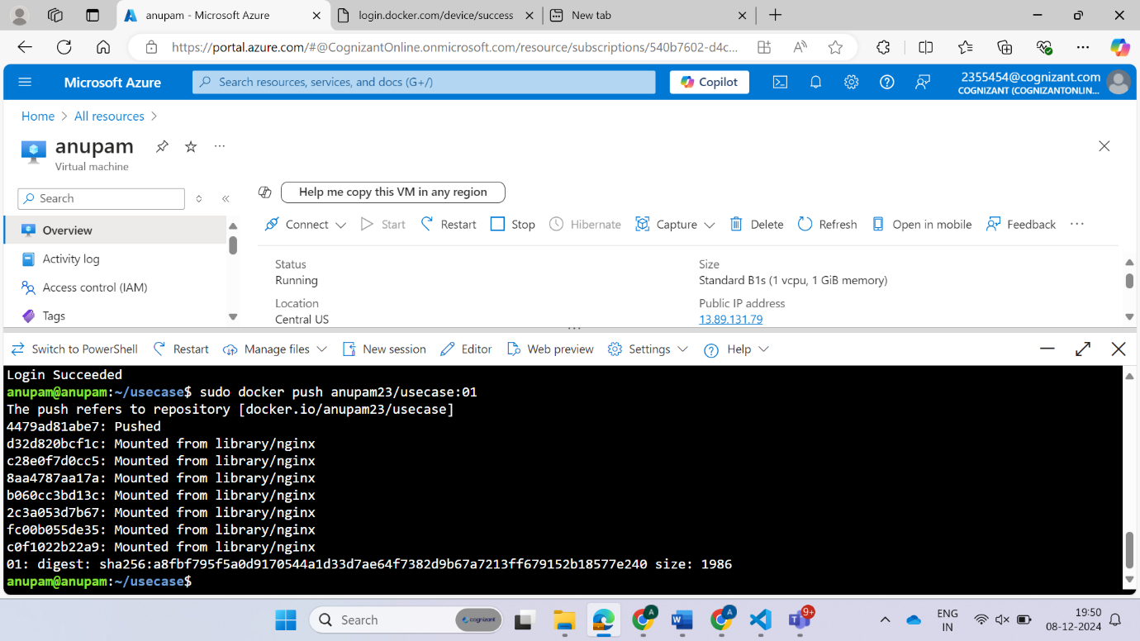

**See Docker images**

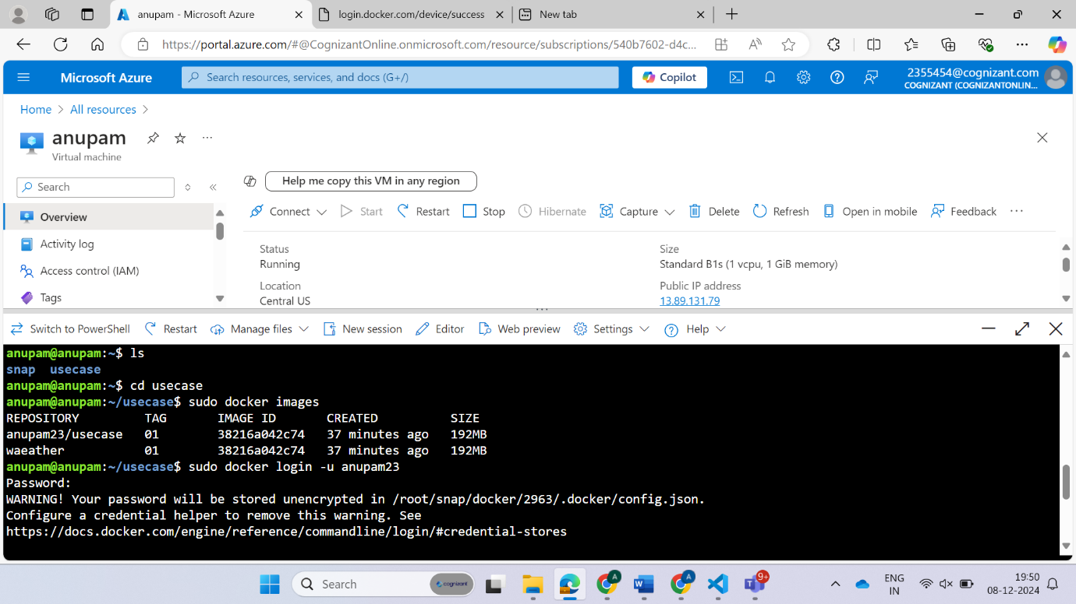

**ACR(Azure Container Registery)**

**Create Azure Container Registry (ACR)**

az acr create --resource-group CDPGenCTechServices-2355454-RG --name anupamregistery --sku Basic

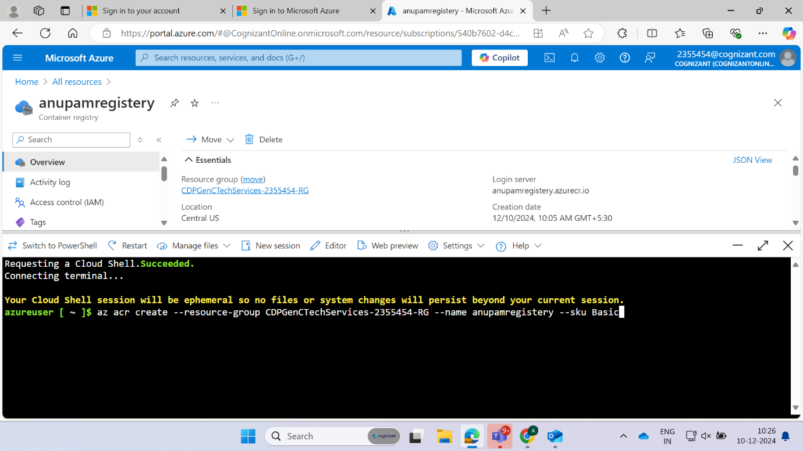

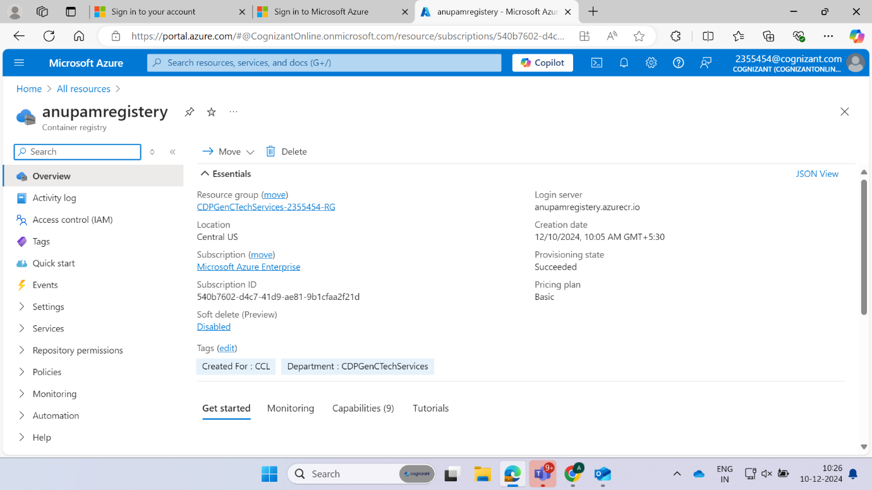

**Login to ACR**

docker login anupamregistery.azurecr.io -u token

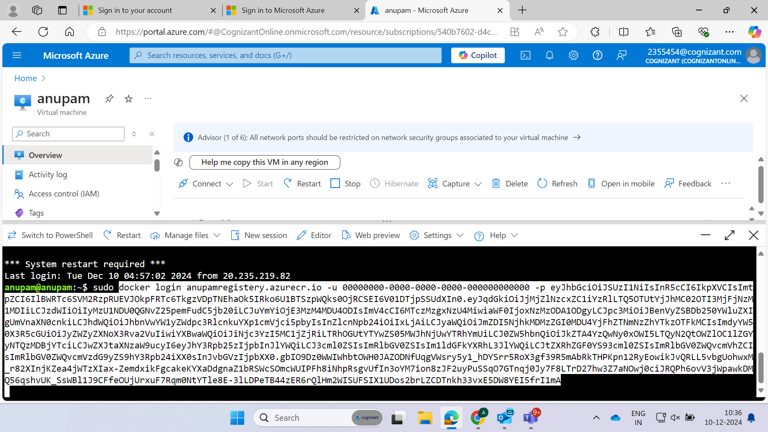

**Tag the Docker Image**

docker tag anupam23/usecase:01 anupamregistery.azurecr.io/anupam23/usecase:01

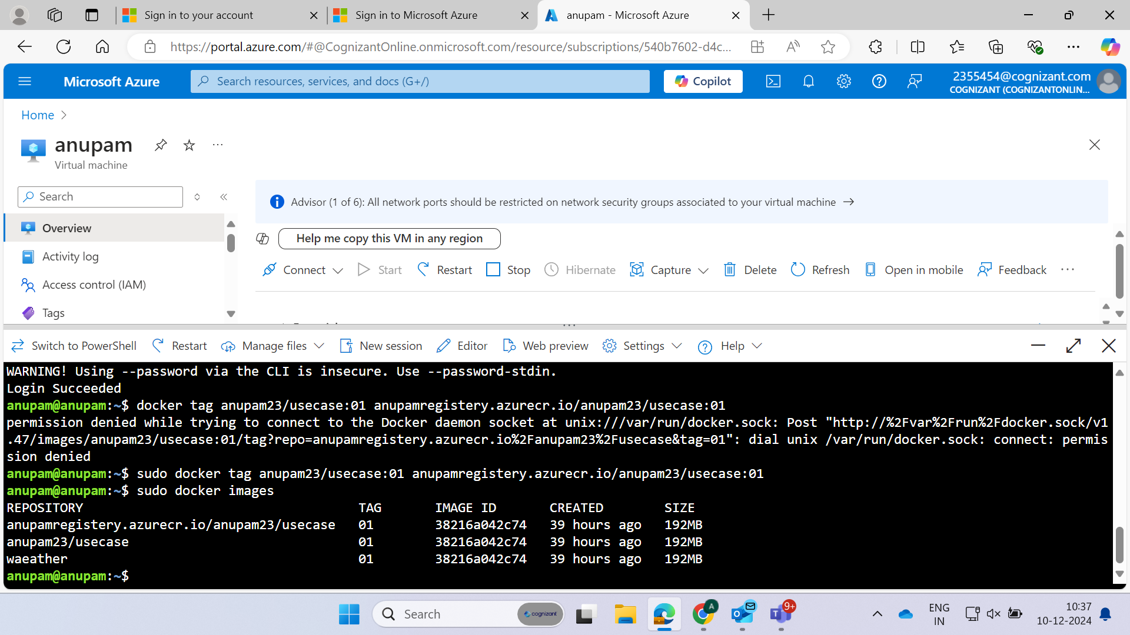

**Push the Docker Image to ACR**

docker push anupamregistery.azurecr.io/anupam23/usecase:01

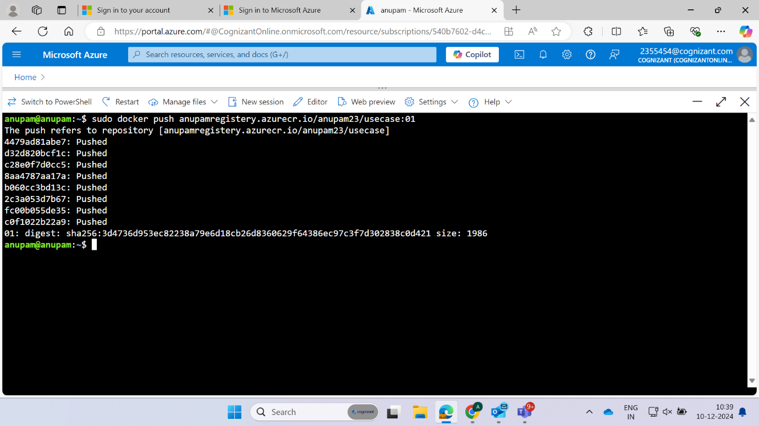

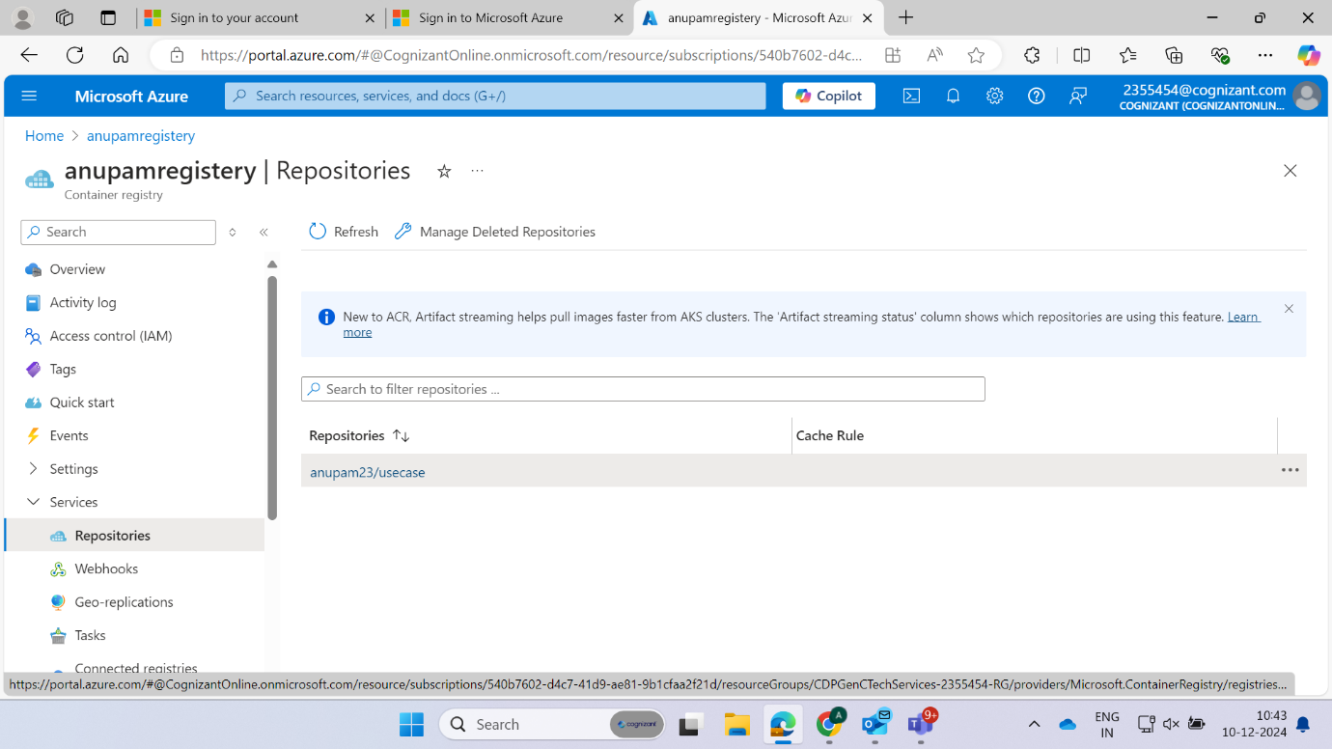

**Create Kubernetes Cluster**

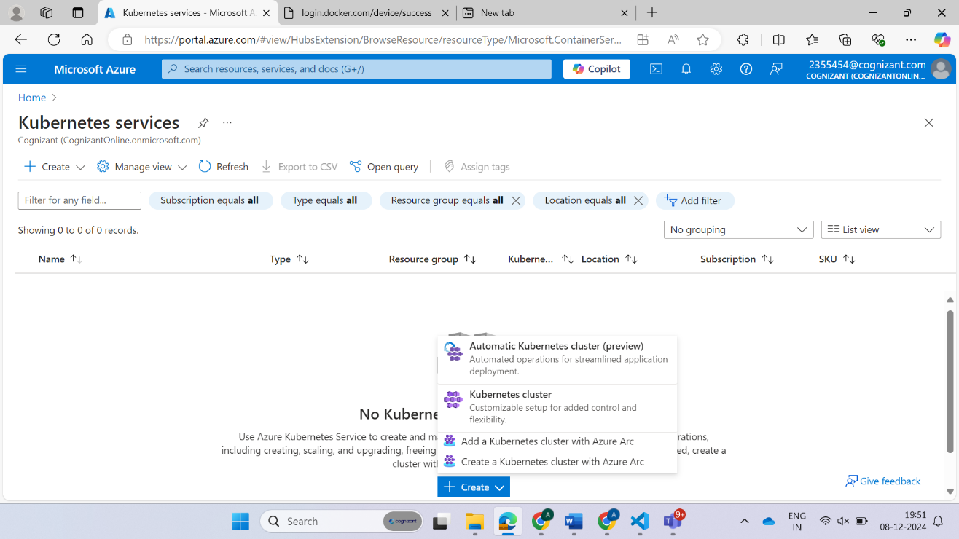

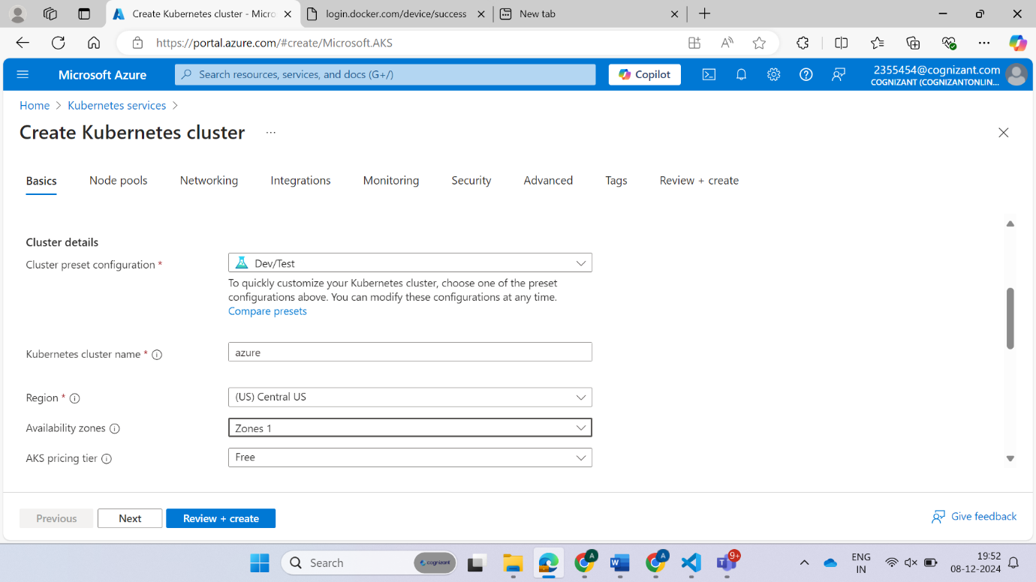

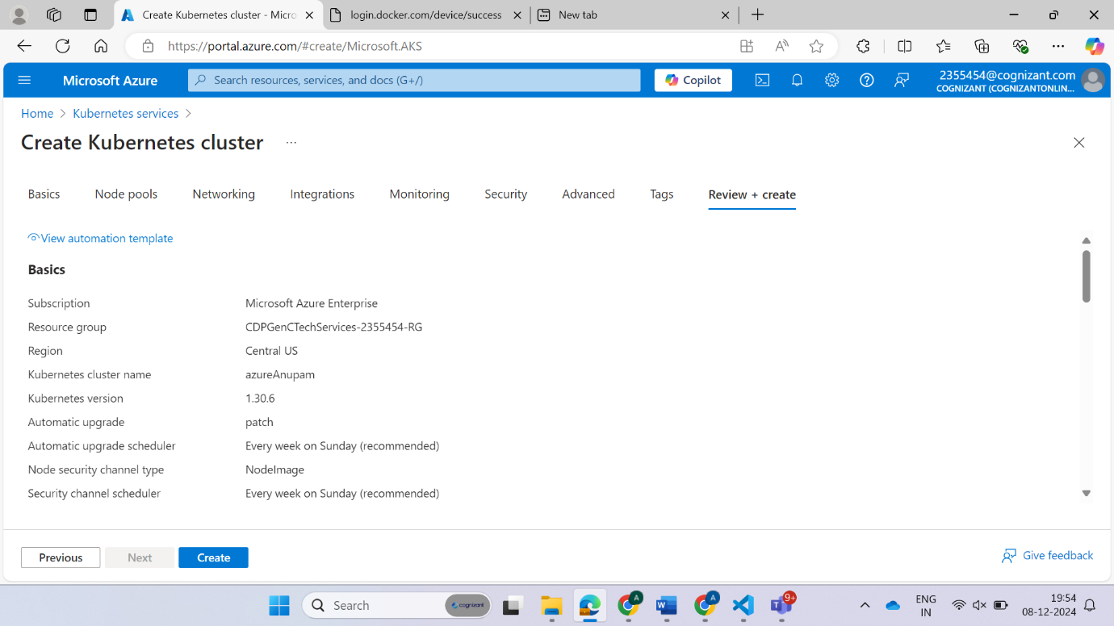

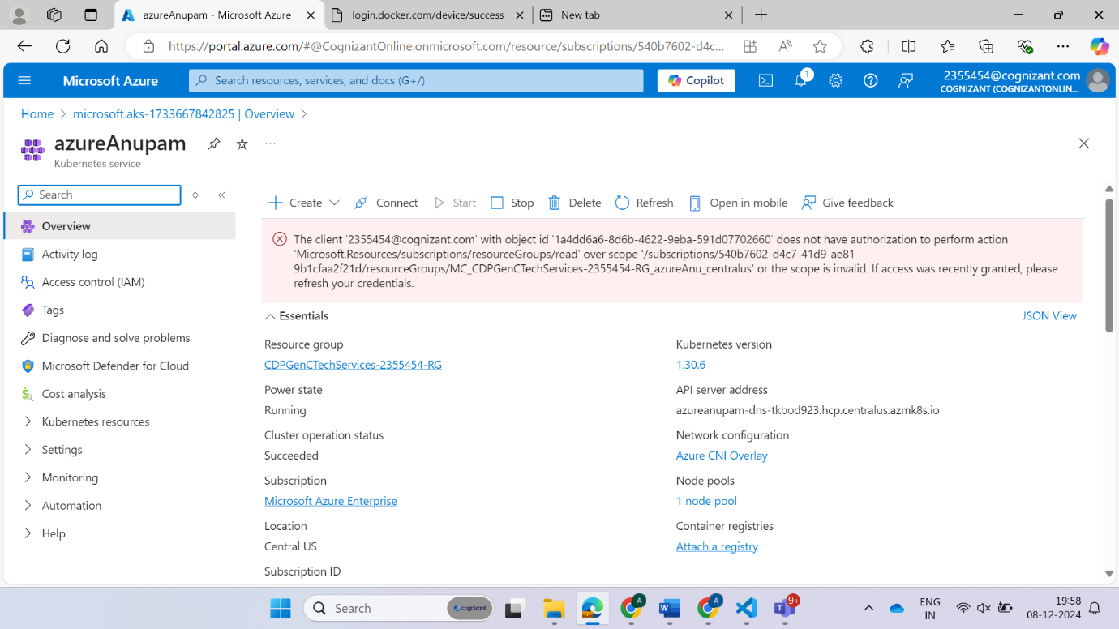

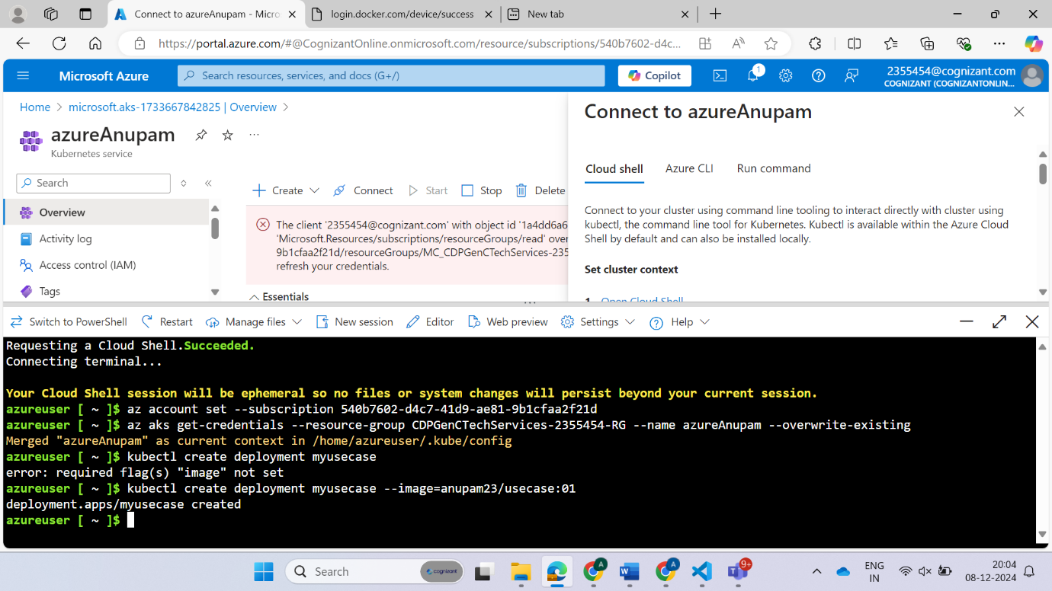

**Deployment.yaml**

apiVersion: apps/v1  
kind: Deployment  
metadata:  
  name: my-deployment  
spec:  
  replicas: 3  
  selector:  
    matchLabels:  
      app: my-app  
  template:  
    metadata:  
      labels:  
        app: my-app  
    spec:  
      containers:  
      - name: my-container  
        image: anupam23/usecase:$(Build.BuildID)  
        ports:  
        - containerPort: 80

kubectl apply -f deployment.yaml

**service.yaml**

apiVersion: v1  
kind: Service  
metadata:  
  name: my-service  
spec:  
  selector:  
    app: my-app  
  ports:  
    - protocol: TCP  
      port: 80  
      targetPort: 80  
  type: LoadBalancer

kubectl apply -f service.yaml

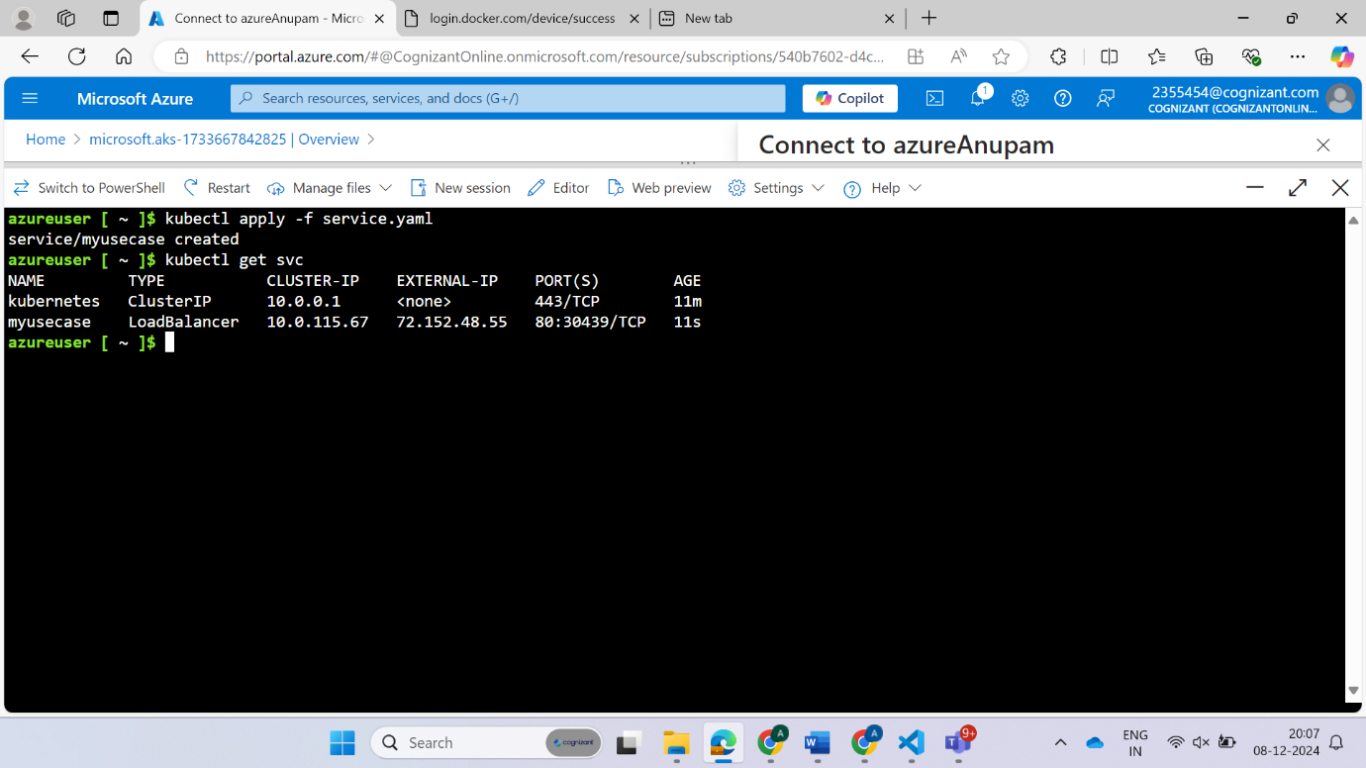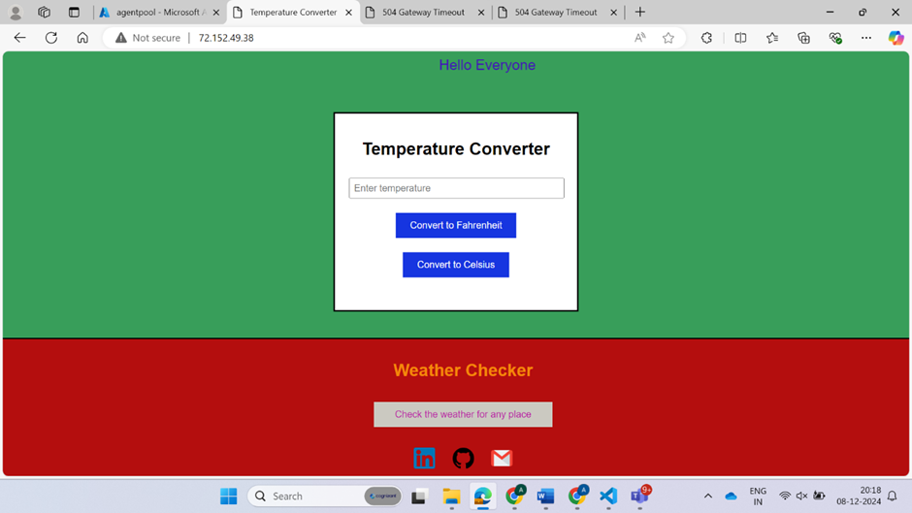

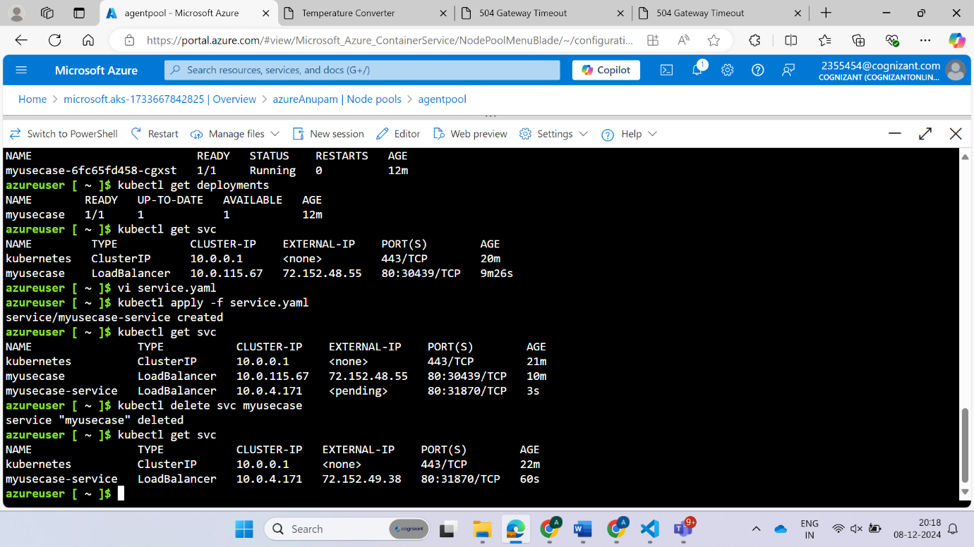

**Automated Deployment Using Azure DevOps Classic Pipeline**

This document provides a step-by-step guide to automate the complete deployment process of a web application using **Azure DevOps Classic Pipeline**. The process includes setting up an **Azure Repository**, creating a build pipeline for CI **(Docker build, Docker push, Azure Artifacts),** and a release pipeline for CD **(deploying using deployment.yaml and service.yaml).**

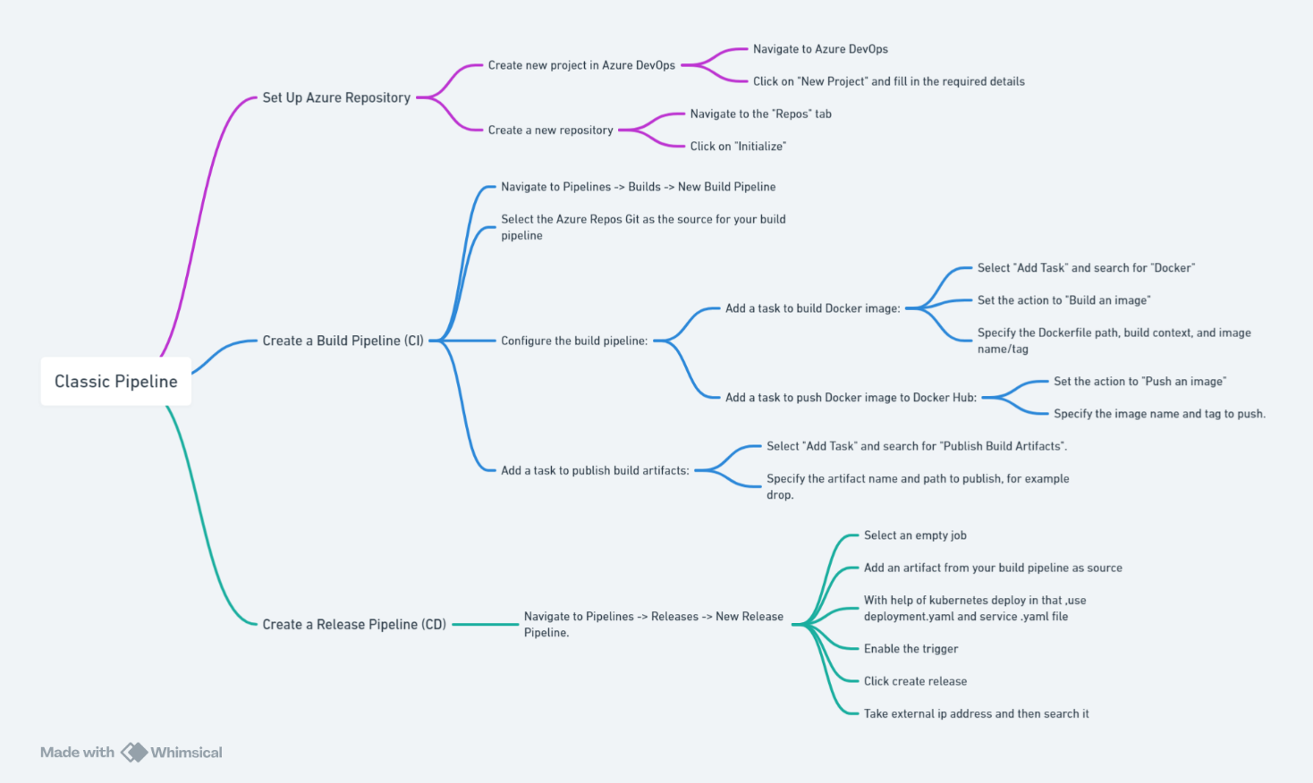

**Steps:**

**1. Set Up Azure Repository**

1. **Create a new project in Azure DevOps**:
   * Navigate to Azure DevOps.
   * Click on "New Project" and fill in the required details.
2. **Create a new repository**:
   * Navigate to the "Repos" tab.
   * Click on "Initialize" to set up a new repository.
   * Clone the repository to your local machine and add your source code, Dockerfile, deployment.yaml, and service.yaml.

**2. Create a Build Pipeline (CI)**

1. **Navigate to Pipelines -> Builds -> New Build Pipeline**.
2. **Select the Azure Repos Git as the source for your build pipeline**.
3. **Configure the build pipeline**:
   * **Add a task to build Docker image**:
     + Select "Add Task" and search for "Docker".
     + Select "Docker" task and add it to the pipeline.
     + Set the action to "Build an image".
     + Specify the Dockerfile path, for example $(Build.SourcesDirectory)/Dockerfile.
     + Set the build context to $(Build.SourcesDirectory).
     + Specify the image name and tag, for example username/hello-world-app:$(Build.BuildId) (replace username with your Docker Hub username).
   * **Add a task to push Docker image to Docker Hub**:
     + Add another "Docker" task.
     + Set the action to "Push an image".
     + Specify the image name and tag to push.
   * **Add a task to publish build artifacts**:
     + Select "Add Task" and search for "Publish Build Artifacts".
     + Specify the artifact name and path to publish, for example drop.

**3. Create a Release Pipeline (CD)**

1. **Navigate to Pipelines -> Releases -> New Release Pipeline**.
2. **Select an empty job** to create a new release pipeline.
3. **Add an artifact**:
   * Select your build pipeline as the source for the artifact.
4. **Define the stages**:
   * Click on "Stage 1" and rename it to "Deploy".
5. **Add tasks to the Deploy stage**:
   * **Azure CLI task to deploy** deployment.yaml:
     + Click on "Add Task".
     + Search for "Azure CLI".
     + Select "Azure CLI" task and add it to the stage.
     + Configure the task with the following settings:
       - **Azure Subscription**: Select your Azure subscription.
       - **Script Location**: Inline script.

**Create a project**

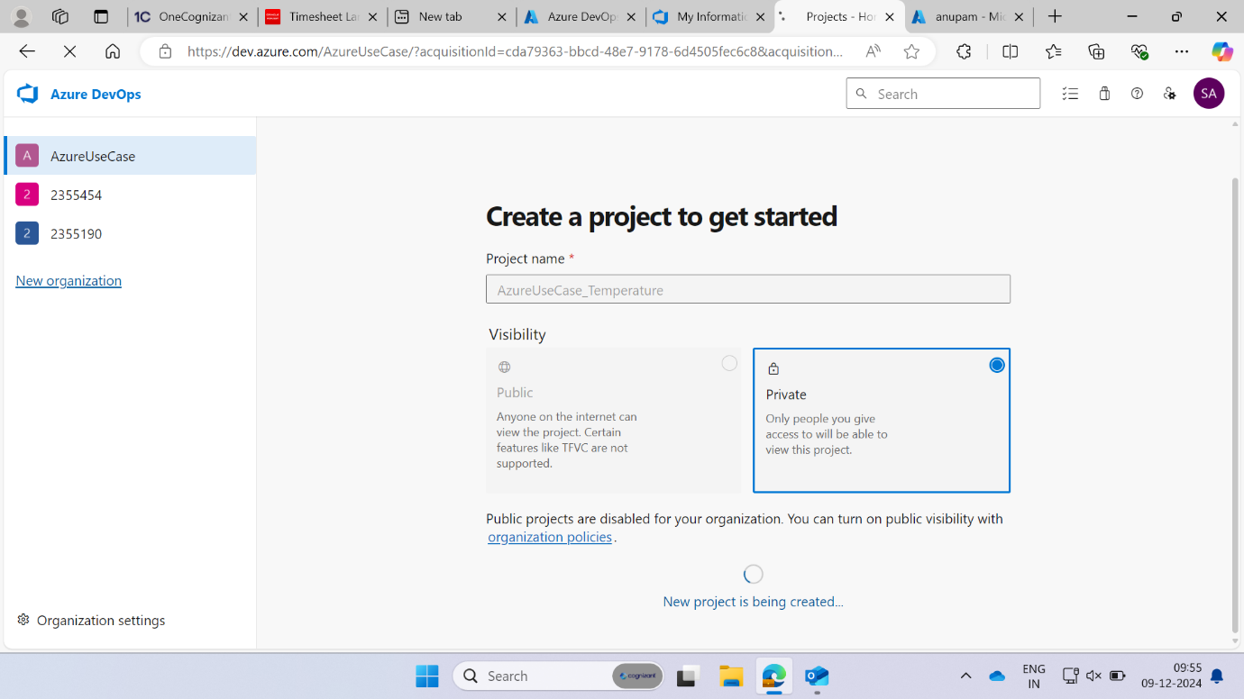

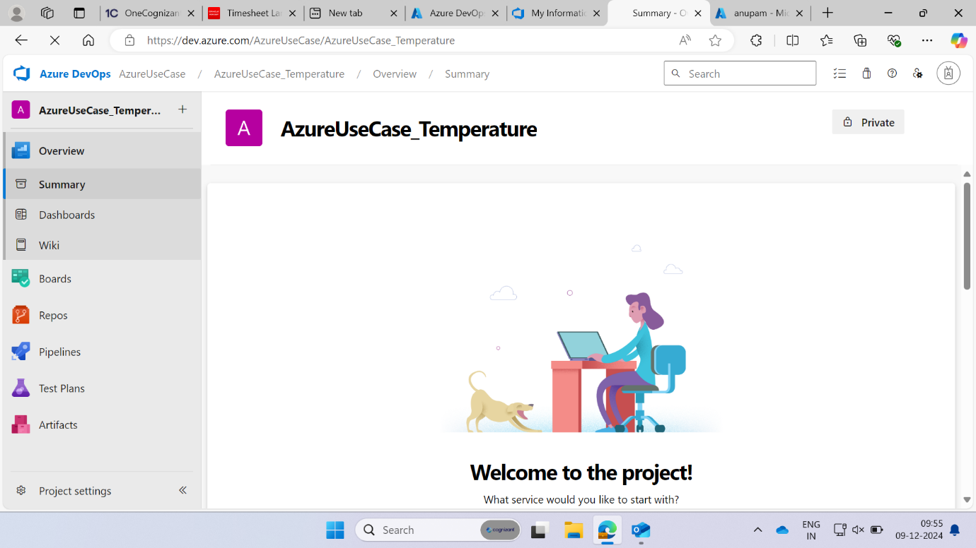

**Git work**

Install git

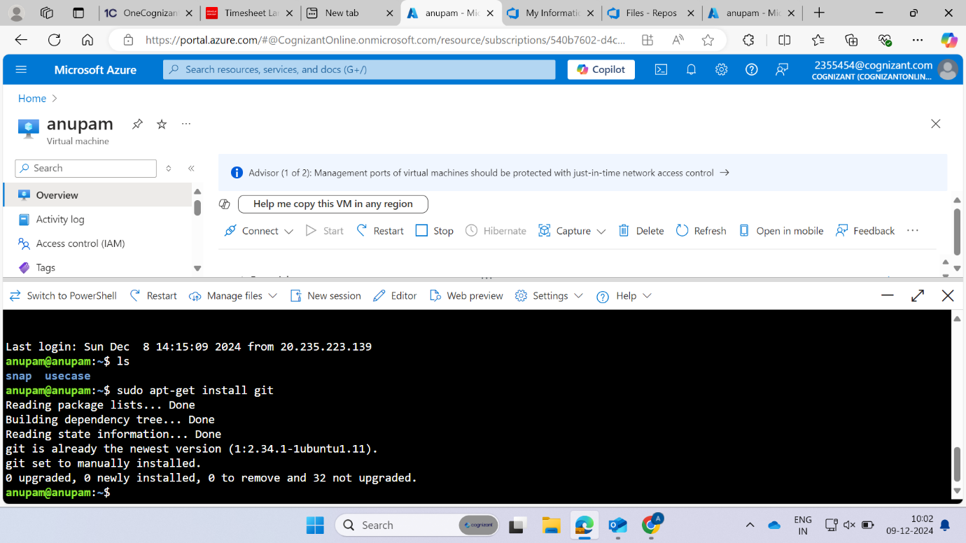

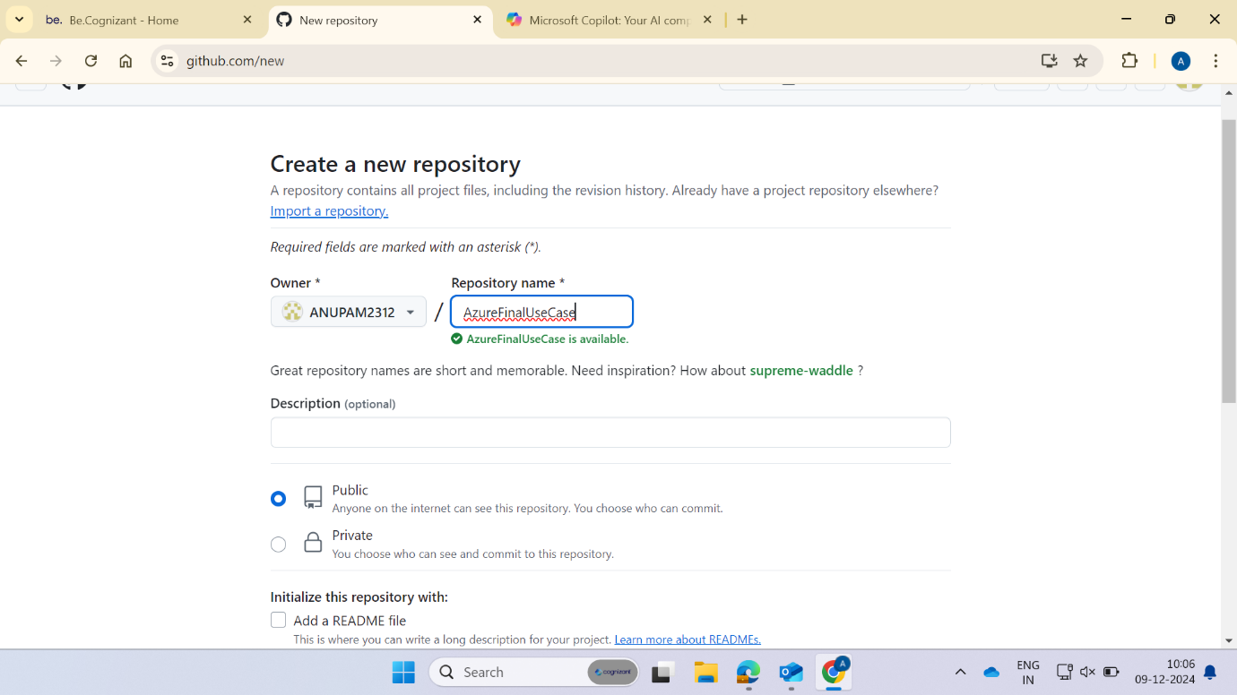

git init

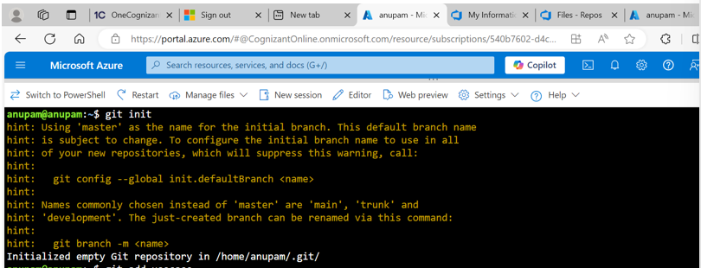

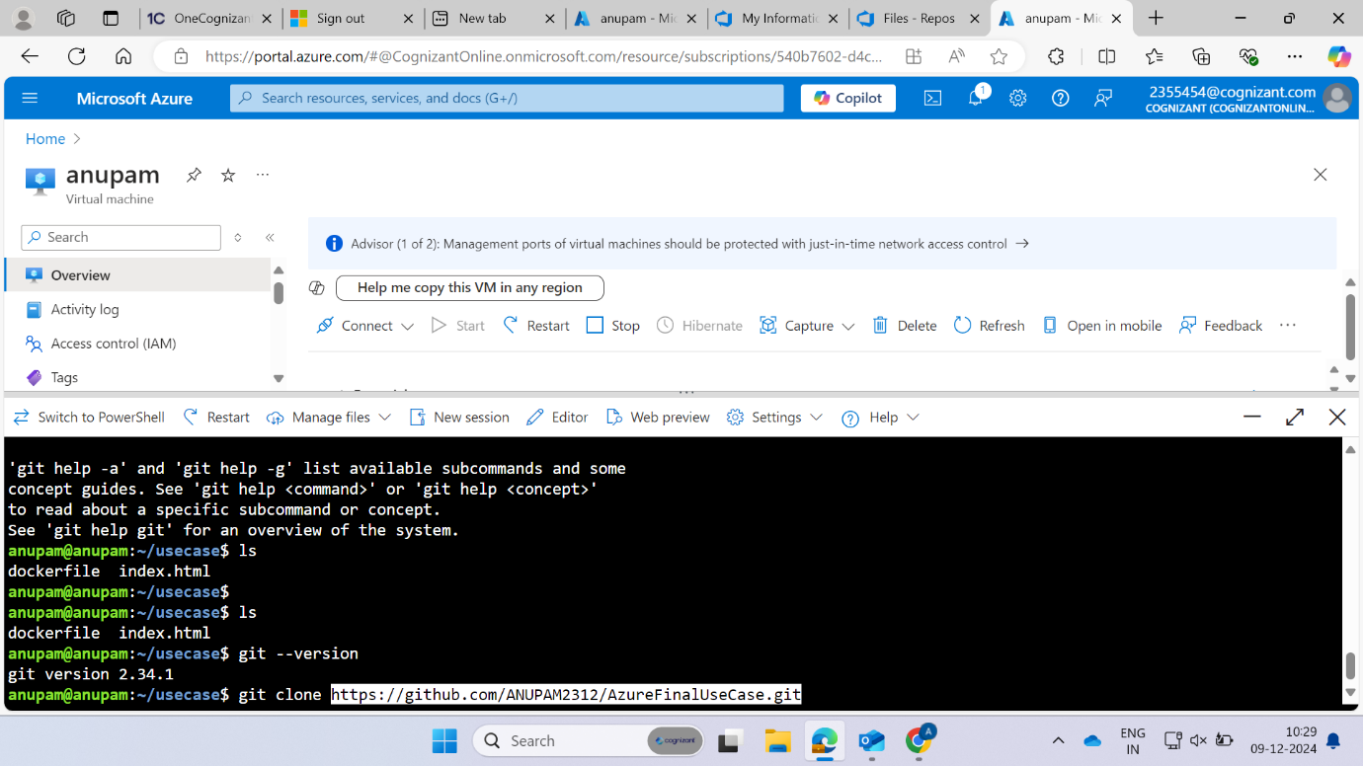

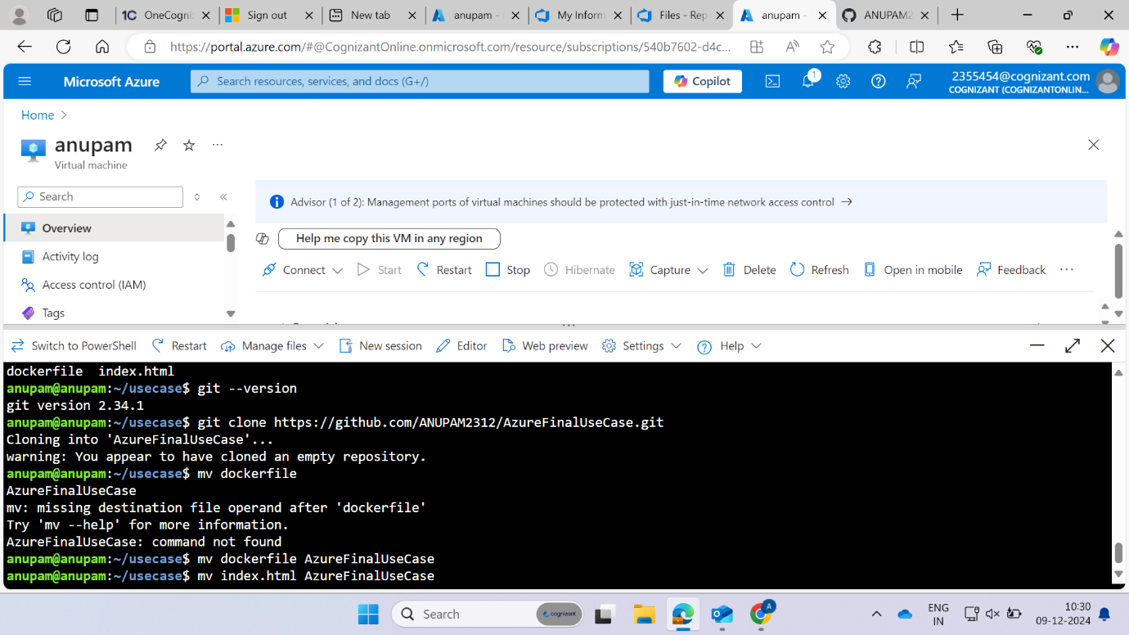

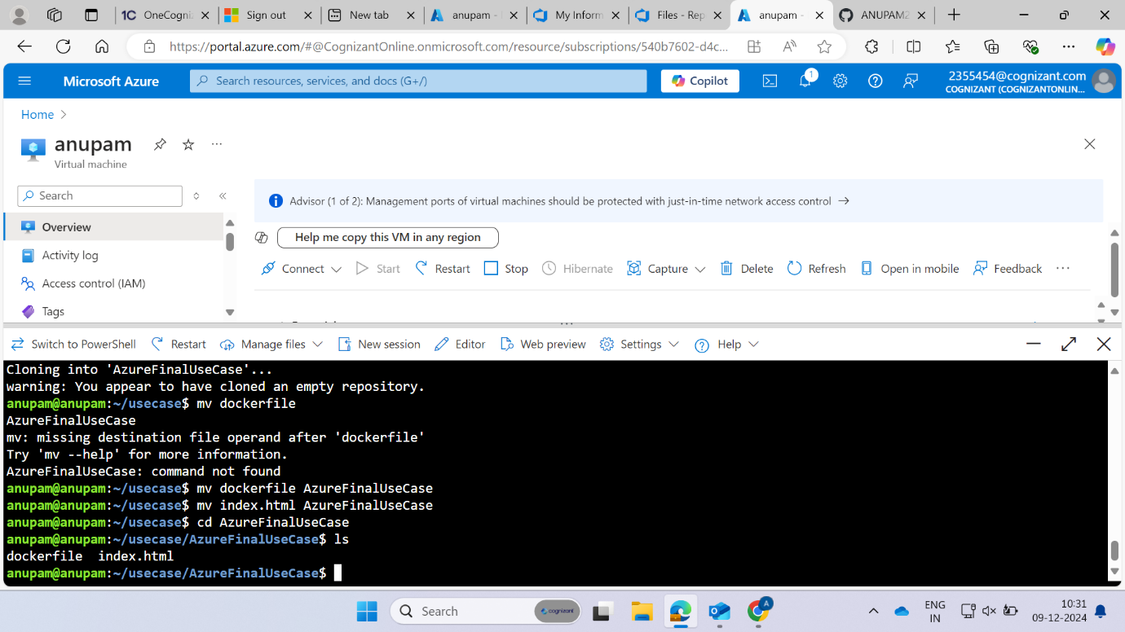



git status

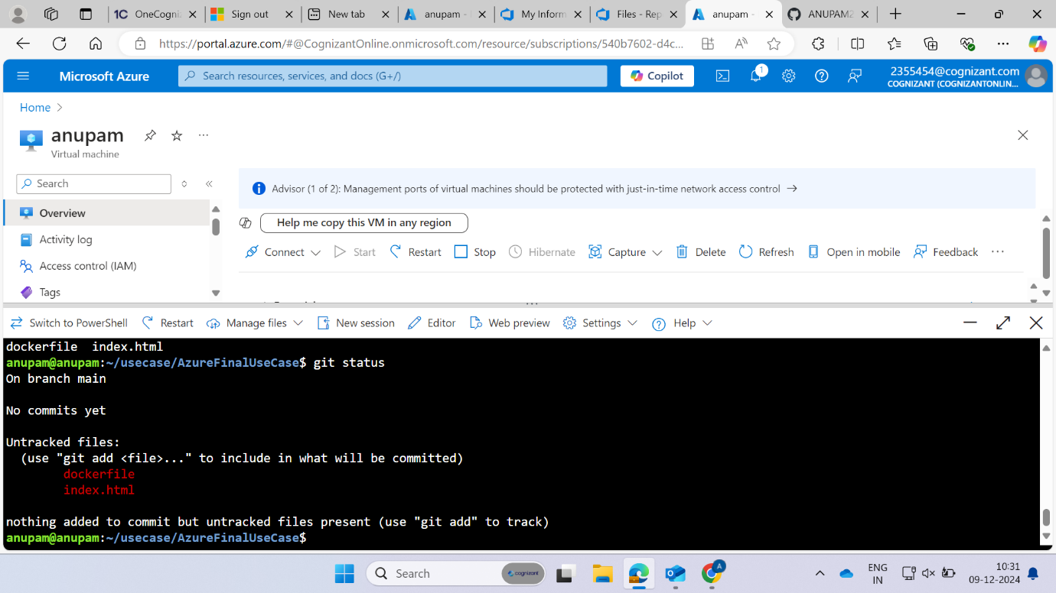

git add .

git commit -m “shukla first commit”

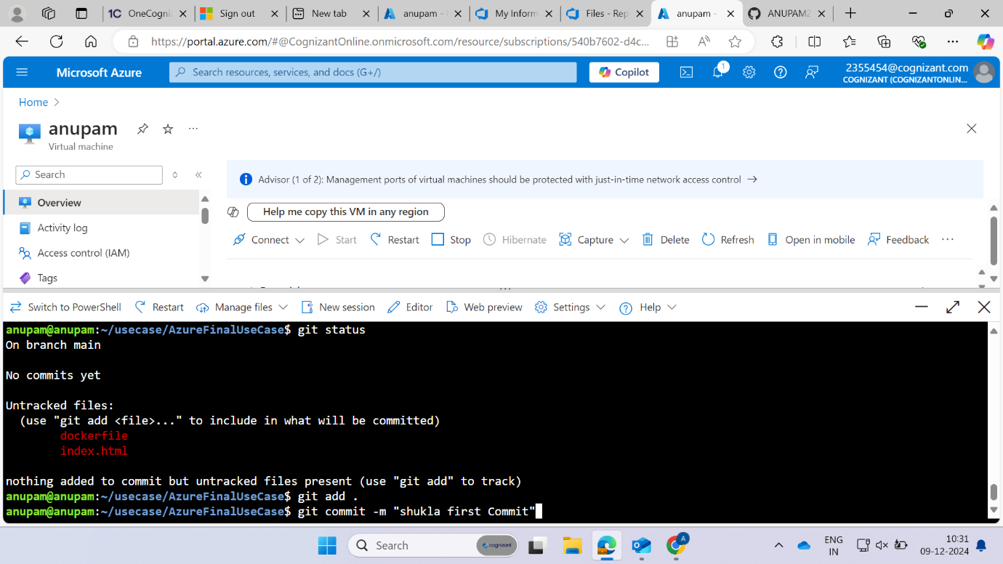

git push origin main

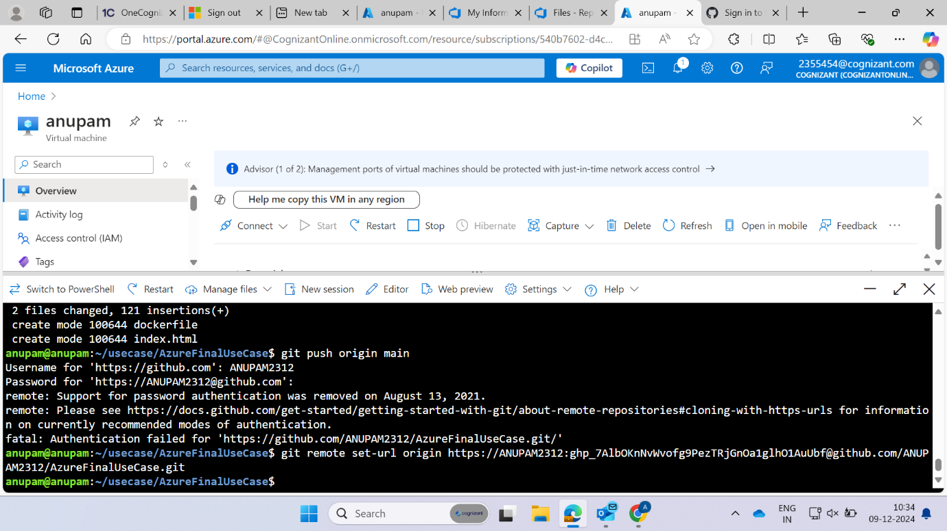

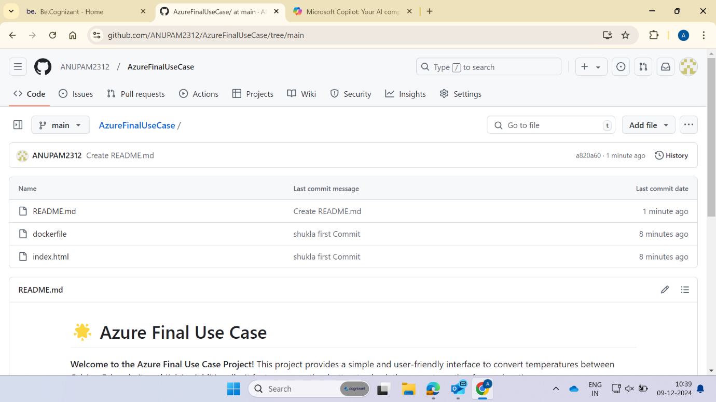

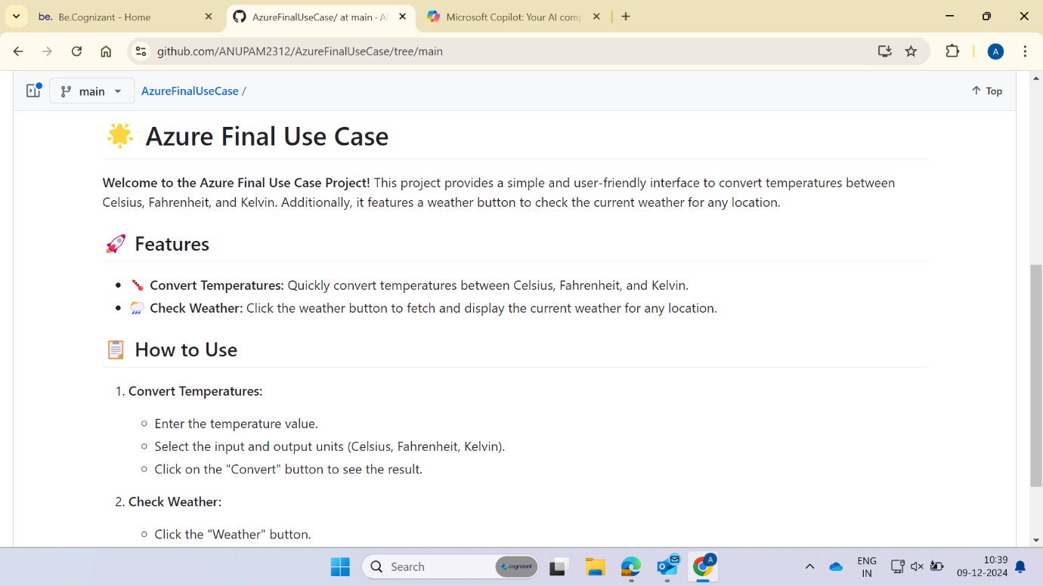

**Azure Repo**

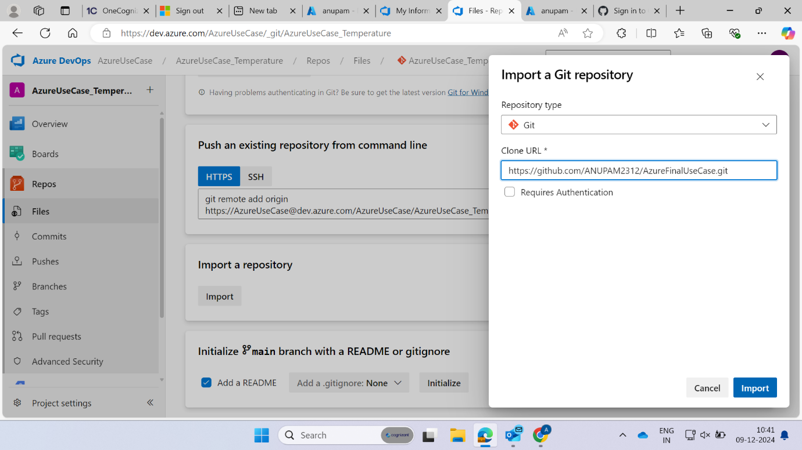

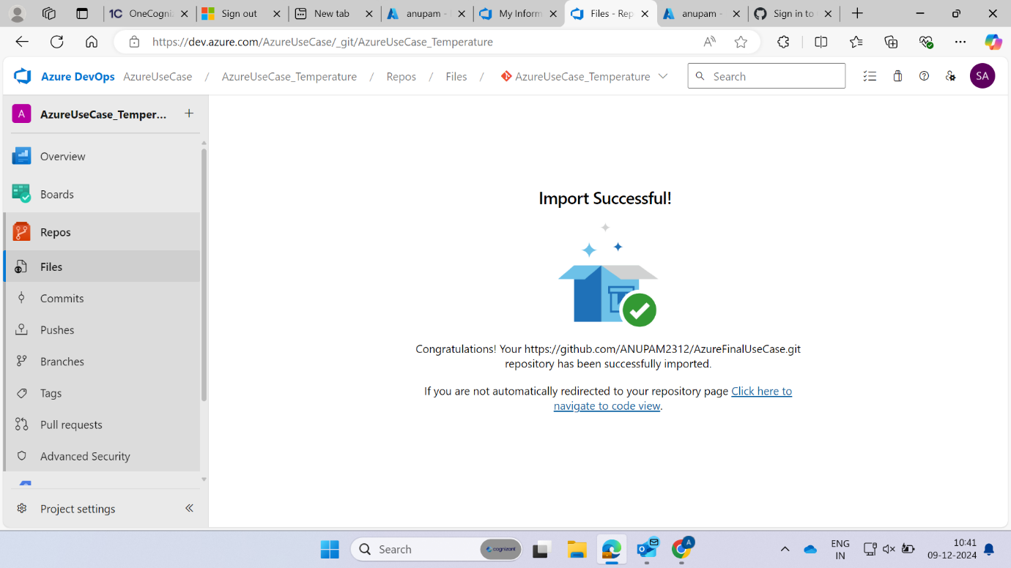

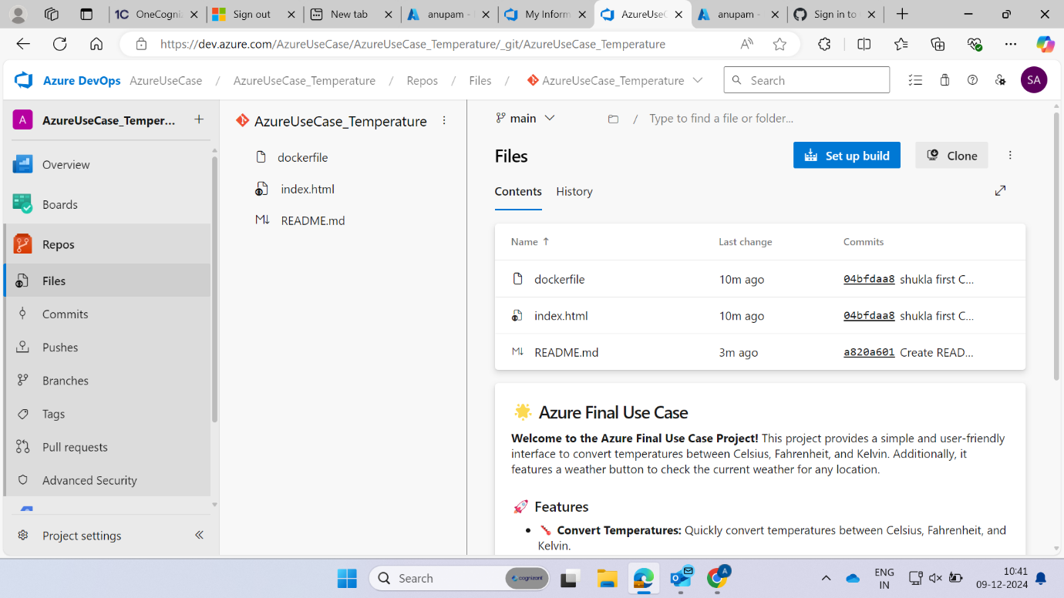



**Pipeline**



Go to organisational settings if classic editor is not showing in your UI=>**So off the disable creation of classic build and classic release**

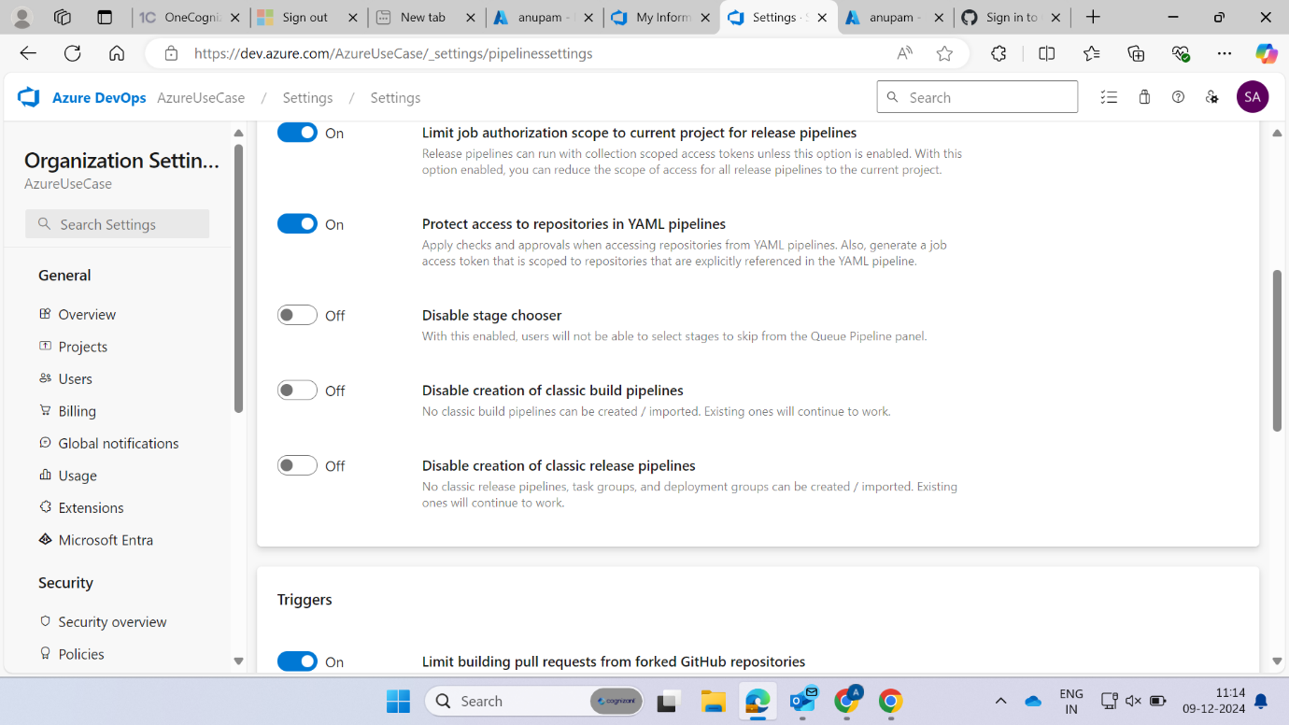

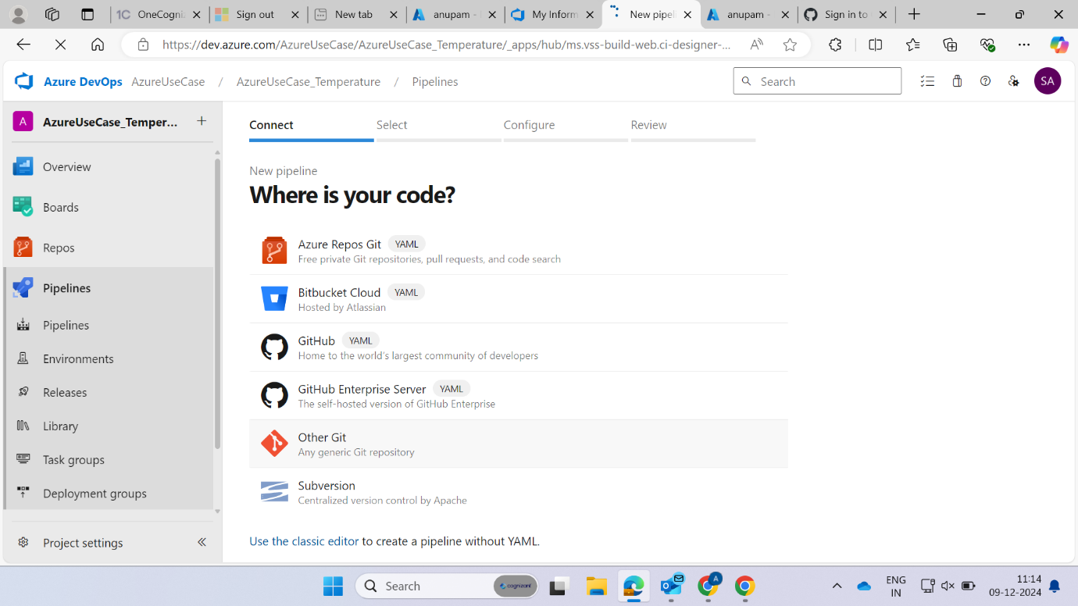

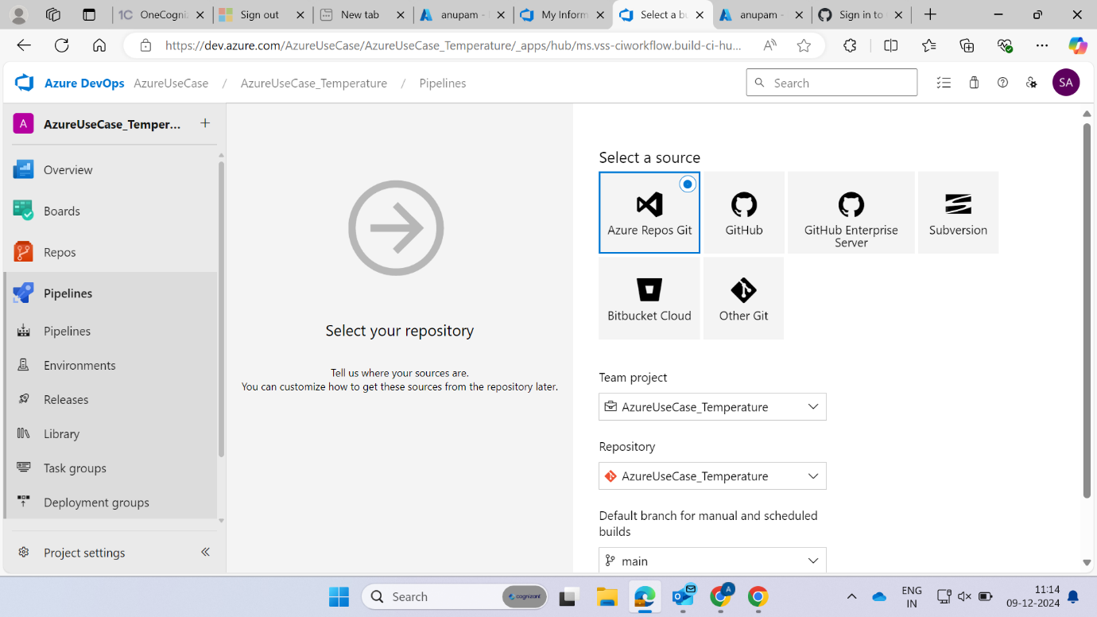

Now select the empty job



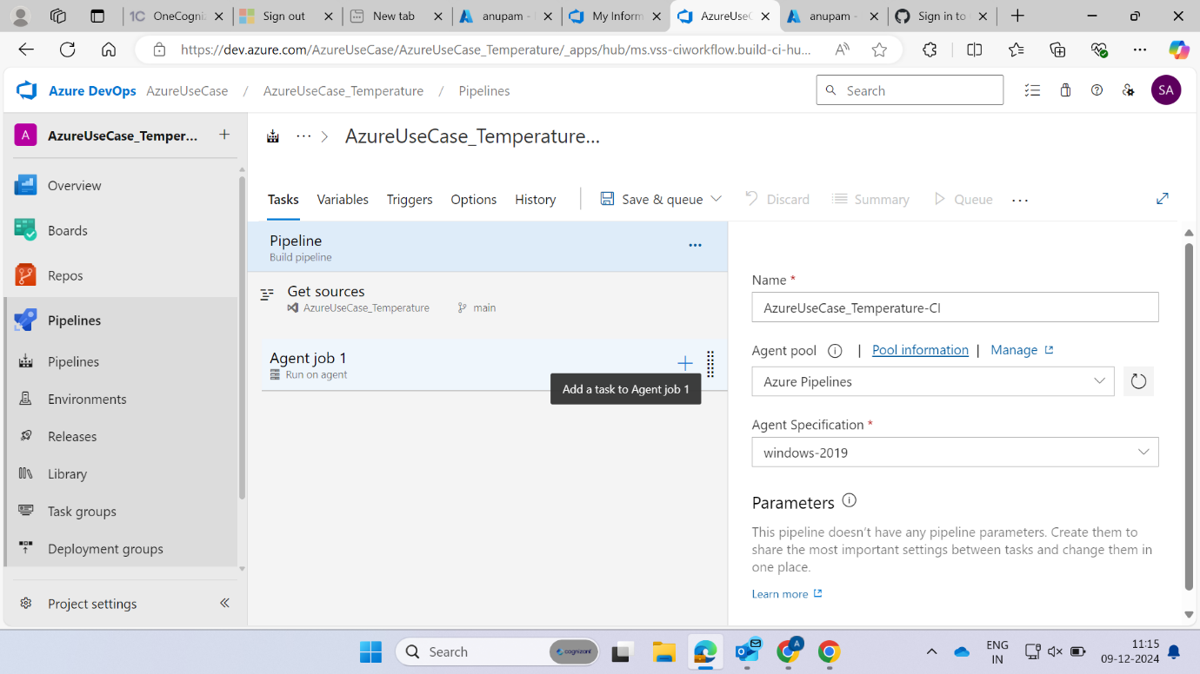

Now your task is to build and push image through docker and for pushing the docker image we use docker hub



**Docker build**



For docker hub connect use dockerhub username and password

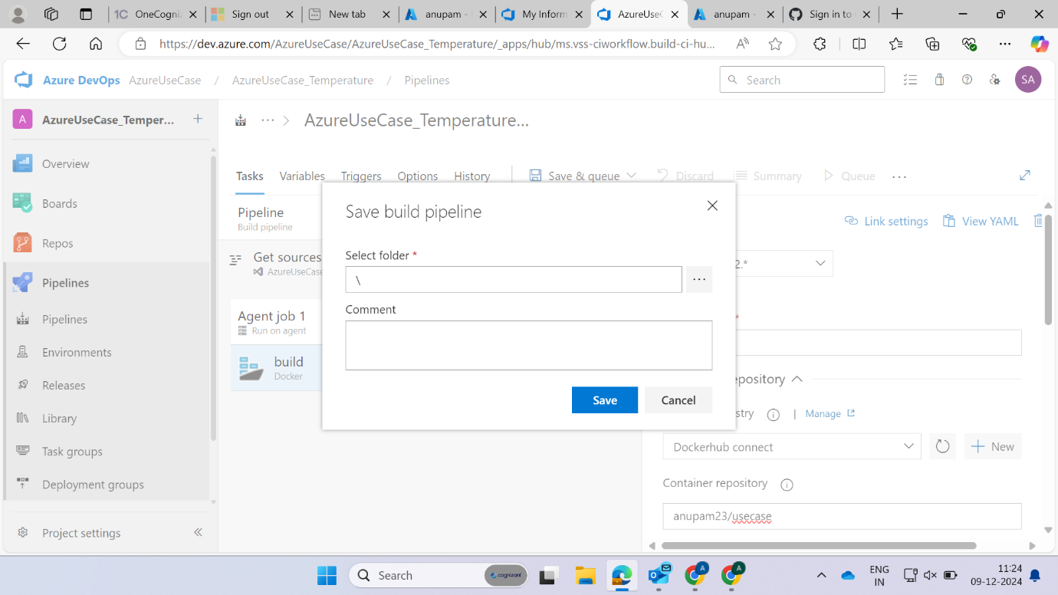

Save it

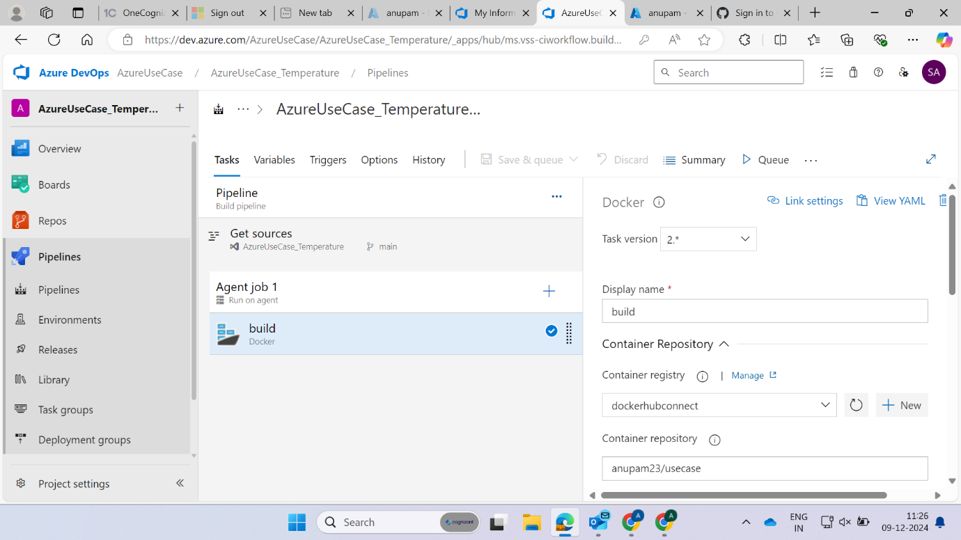

**Docker push**

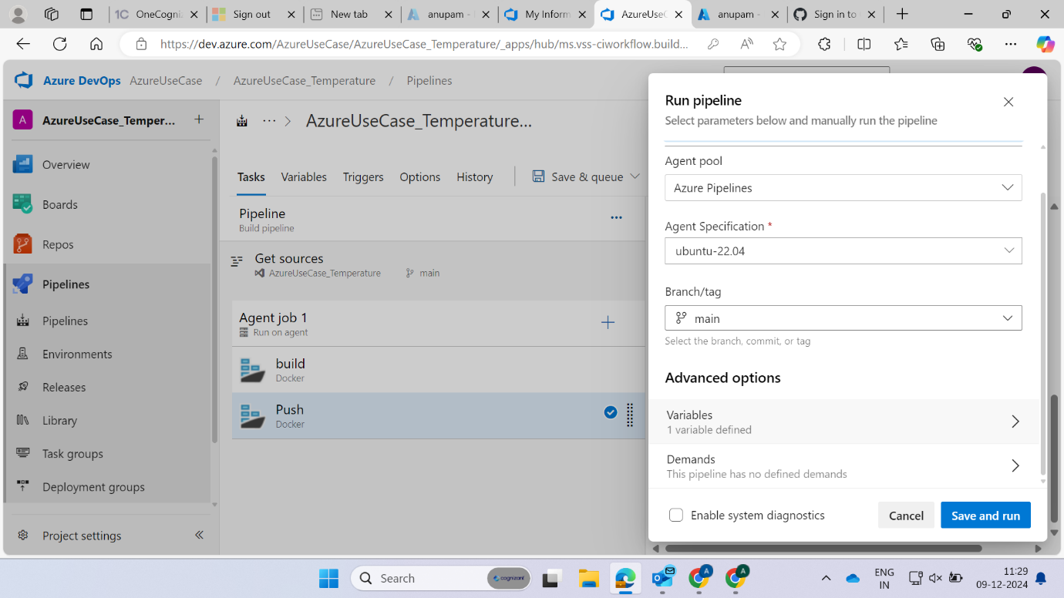

**Artifact**

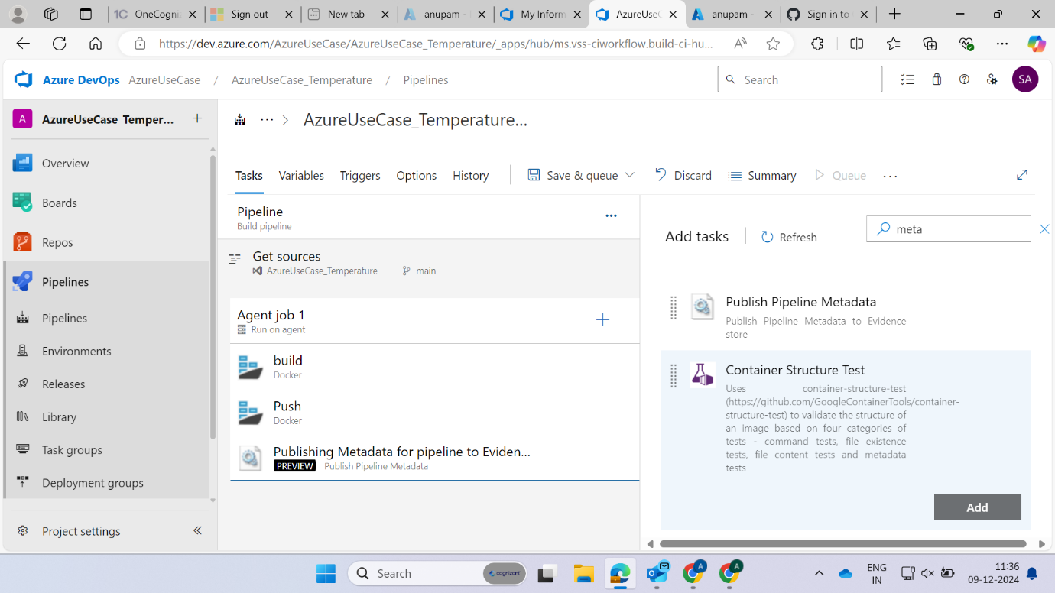

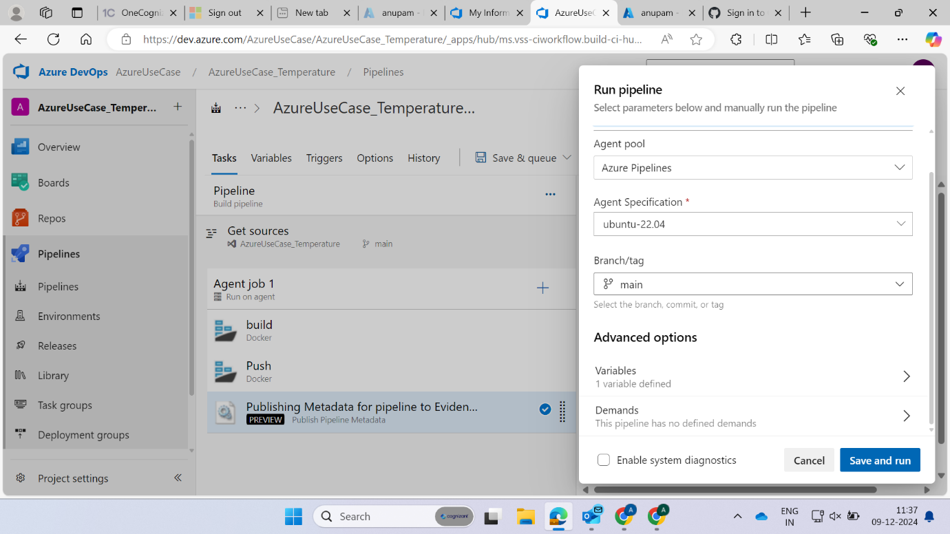

Now save and run as well as save and queue

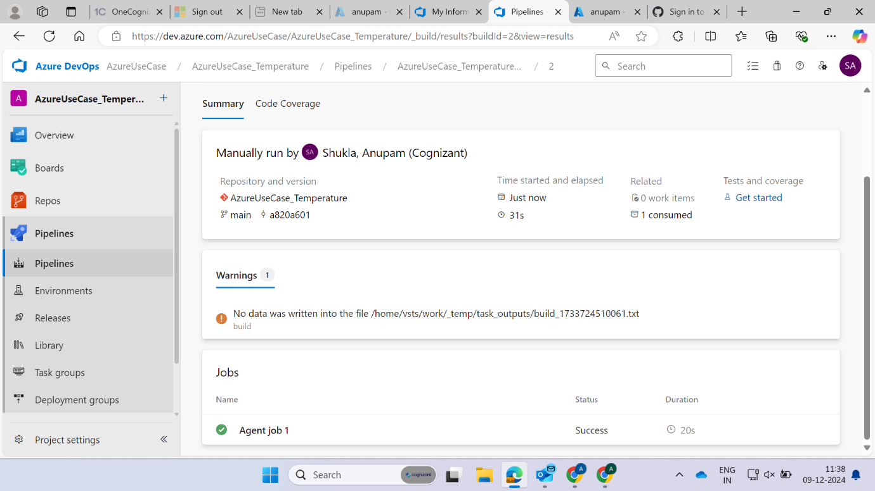



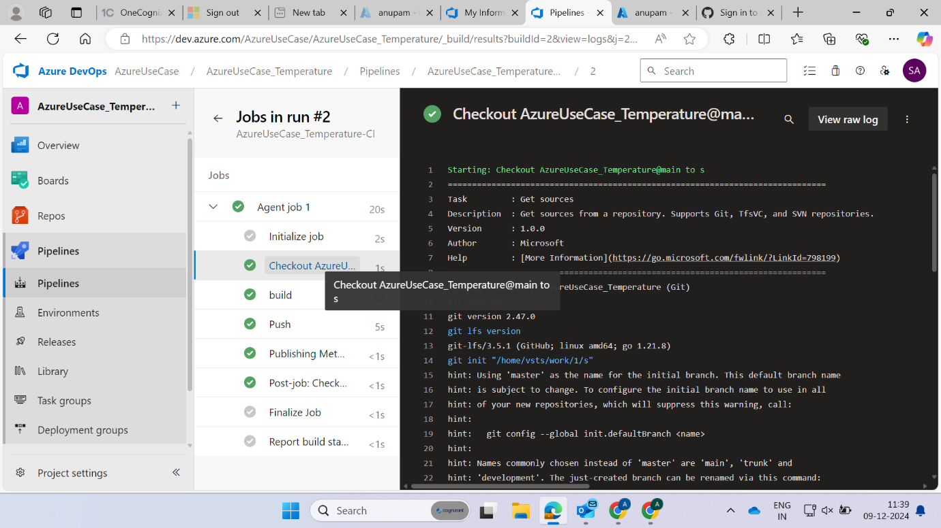

**Release pipeline**

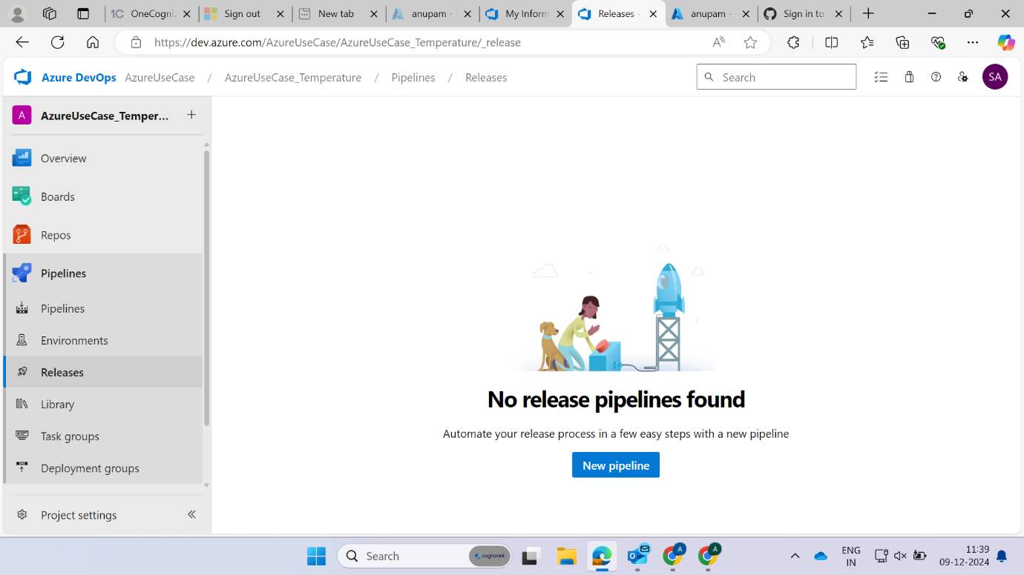

**Use Deploy to kubernetes**

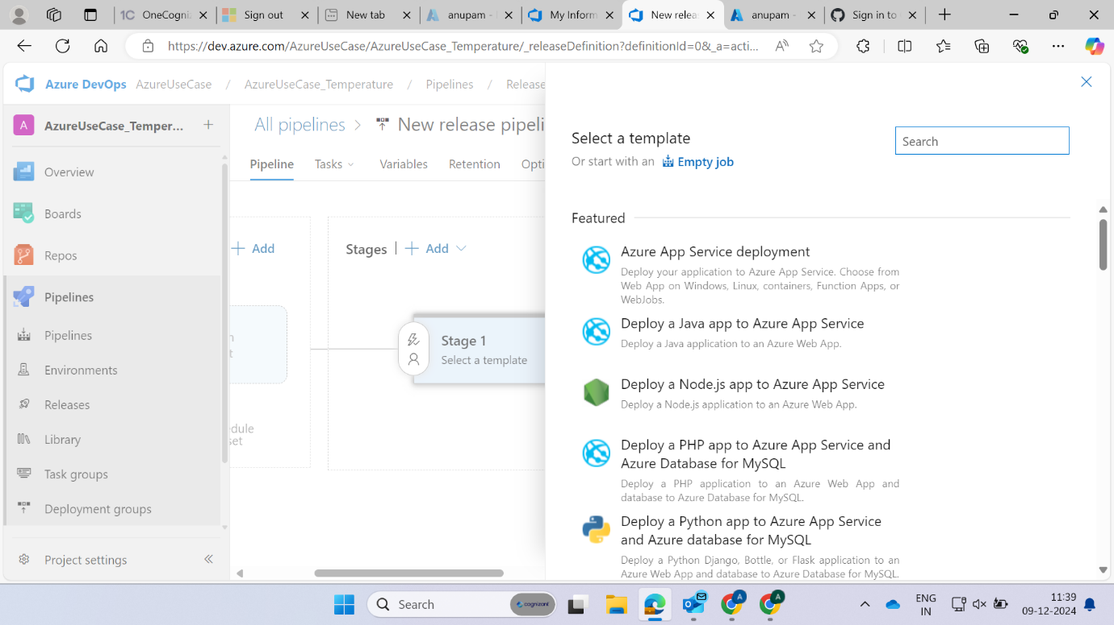

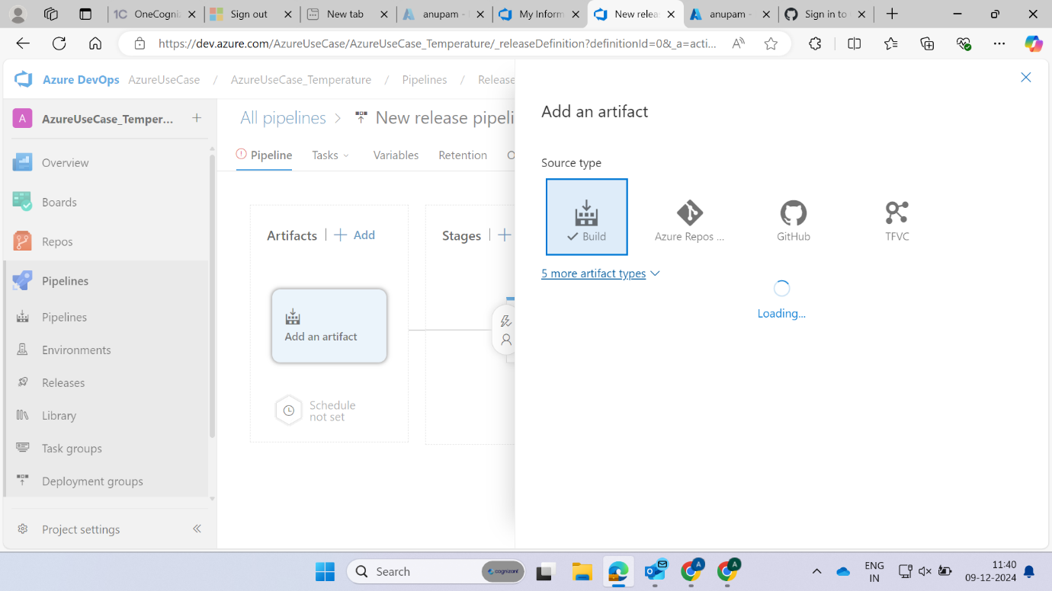

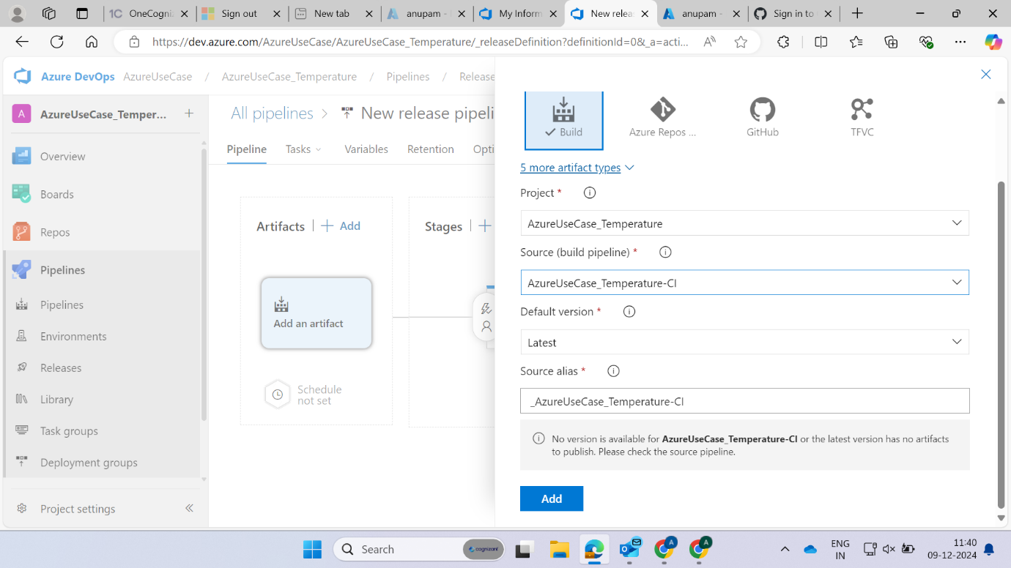

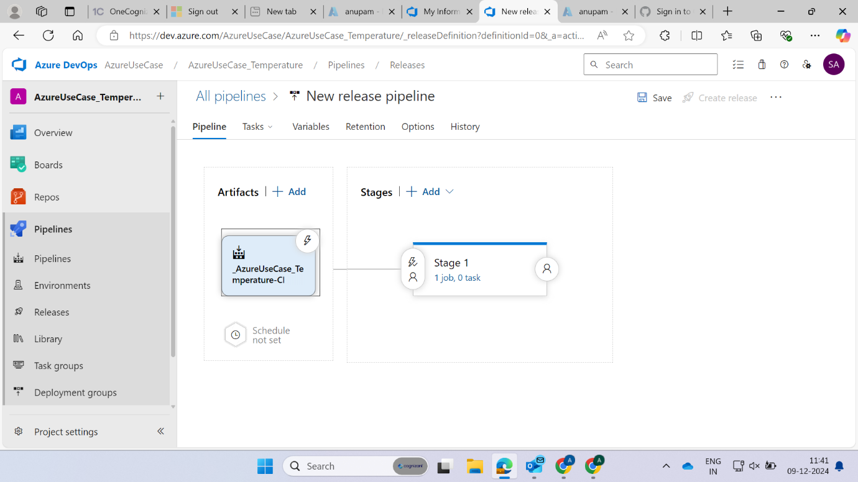

**Enable continuous deployment trigger**

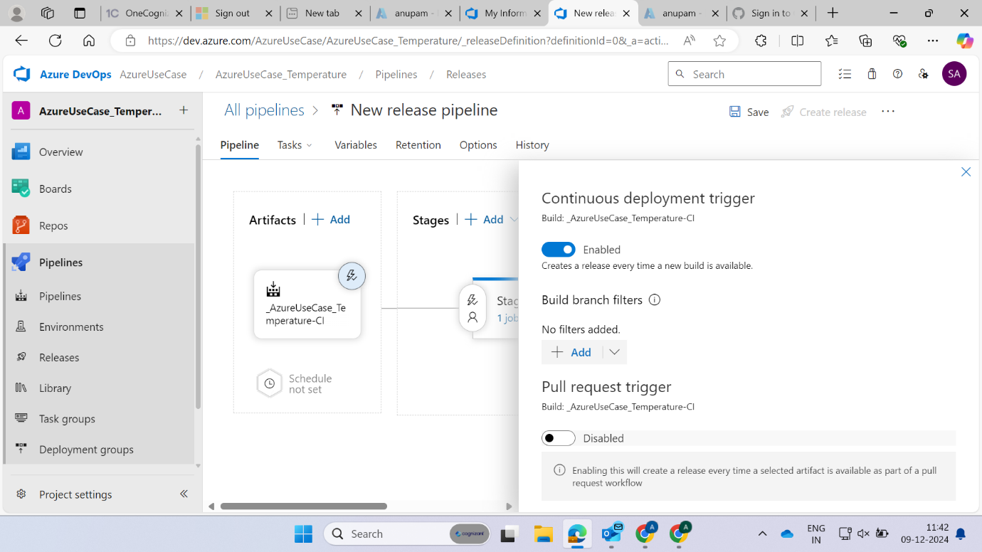

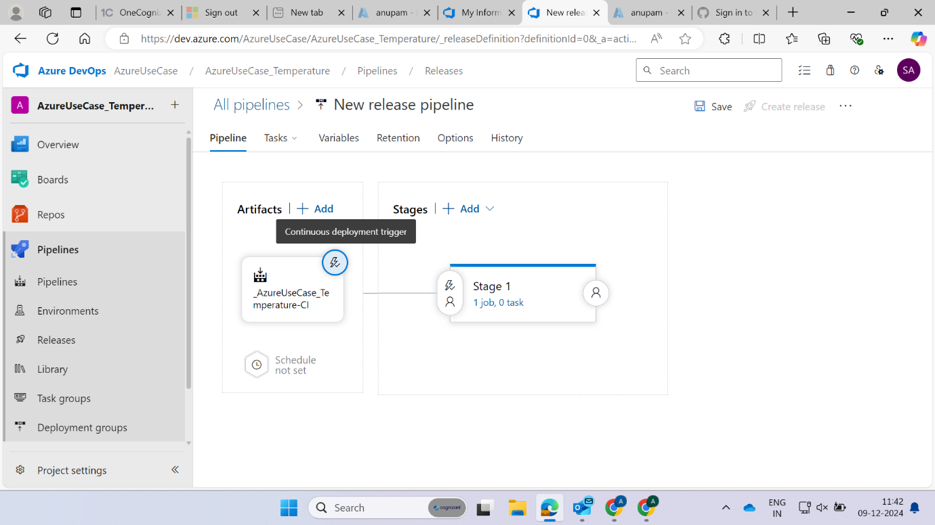

**Earlier in azure repo you don’t have service.yaml and deployment.yaml file so add in that or create it**

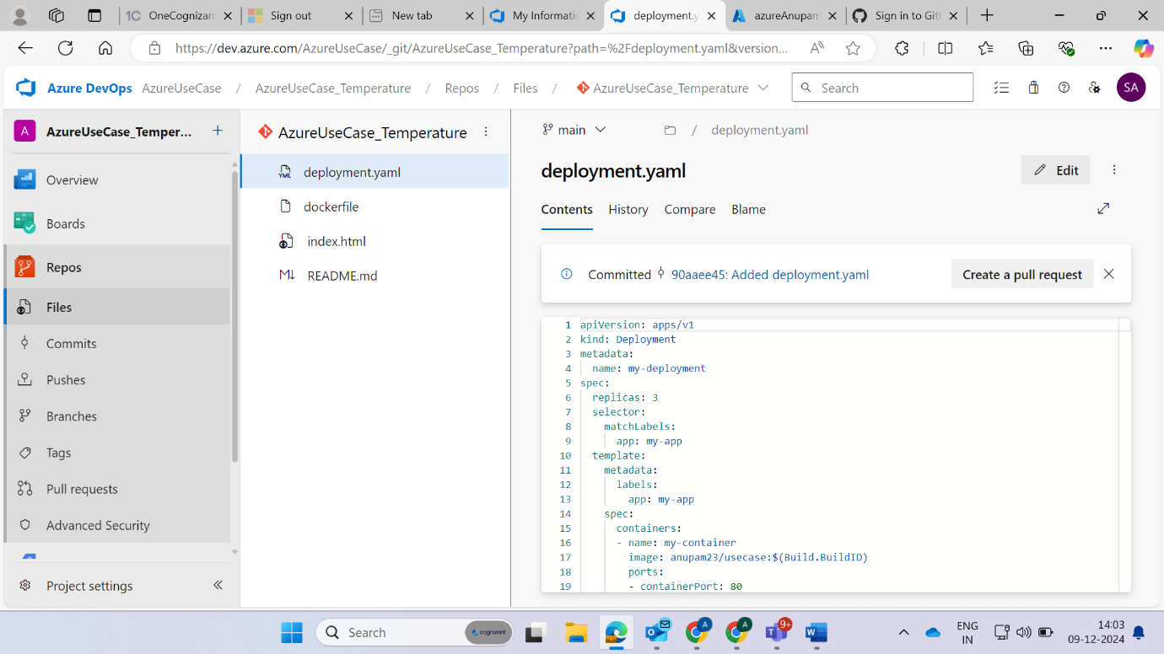



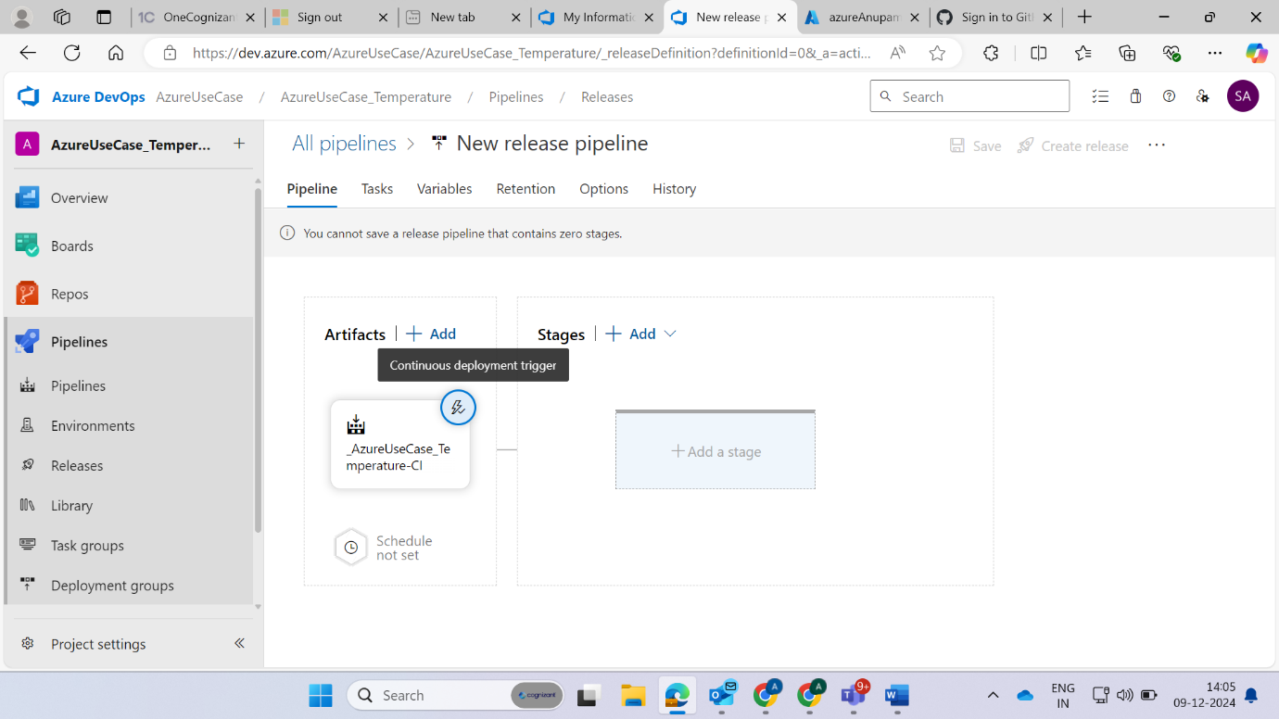

**Now choose Kubernetes deploy**

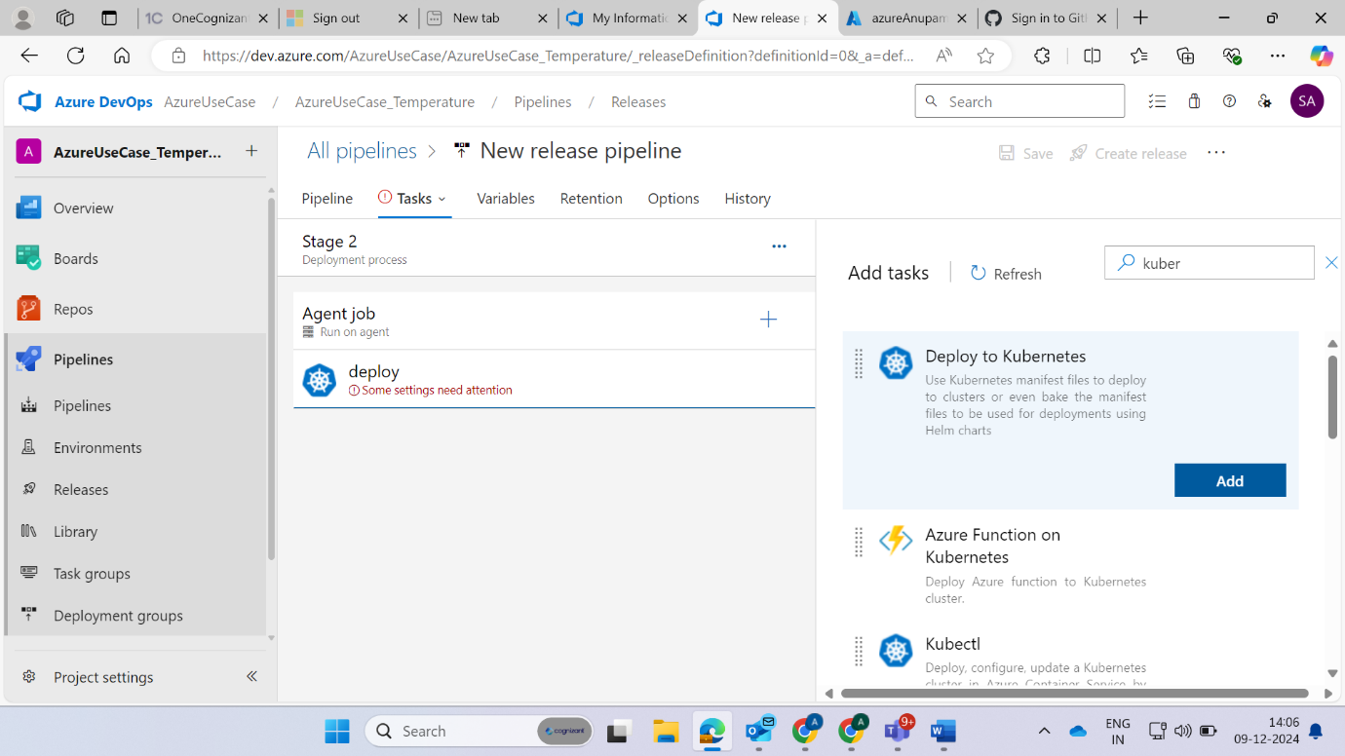

**For that we need Kubernetes cluster connection so go to your Kubernetes cluster and from there open the cloud shell and type cat .kube/config and copy the text which it generate because it will used to setup connection and paste in KubeConfig**

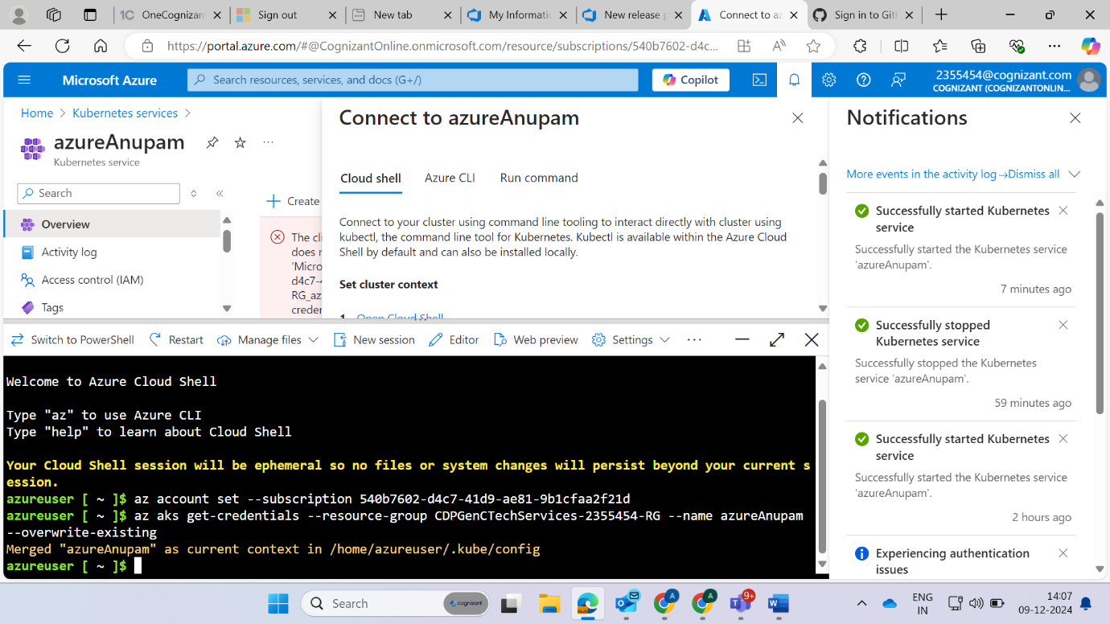

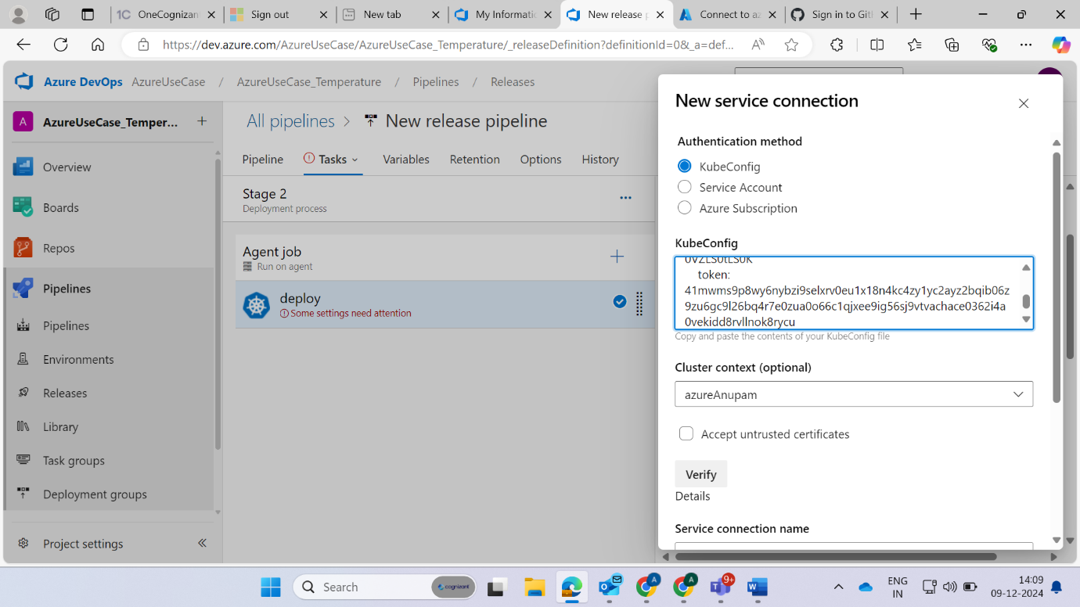

Then verify

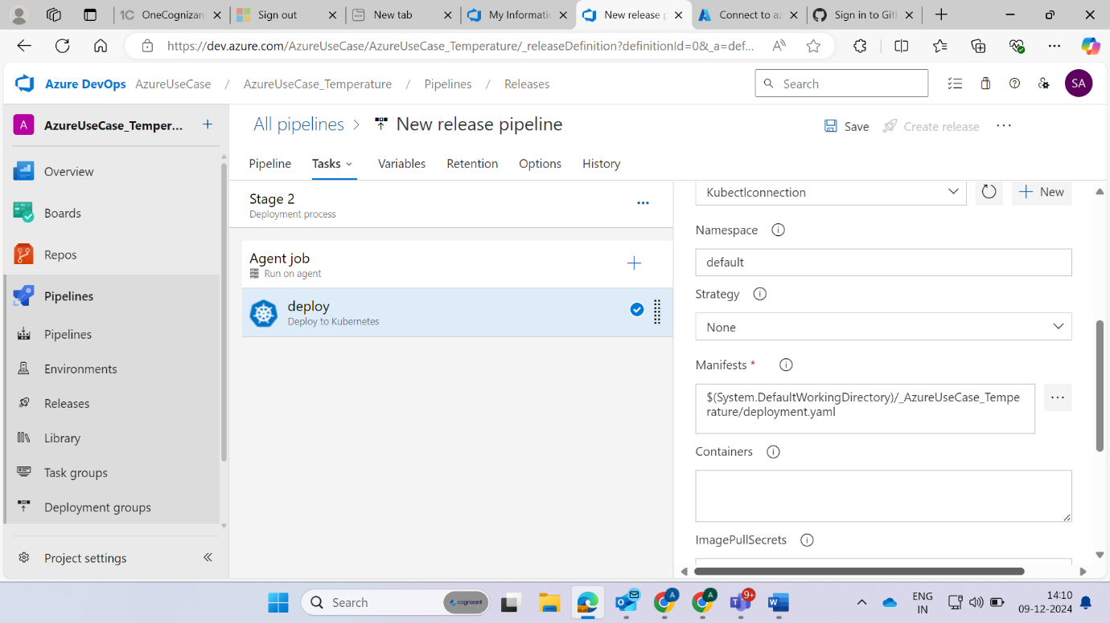

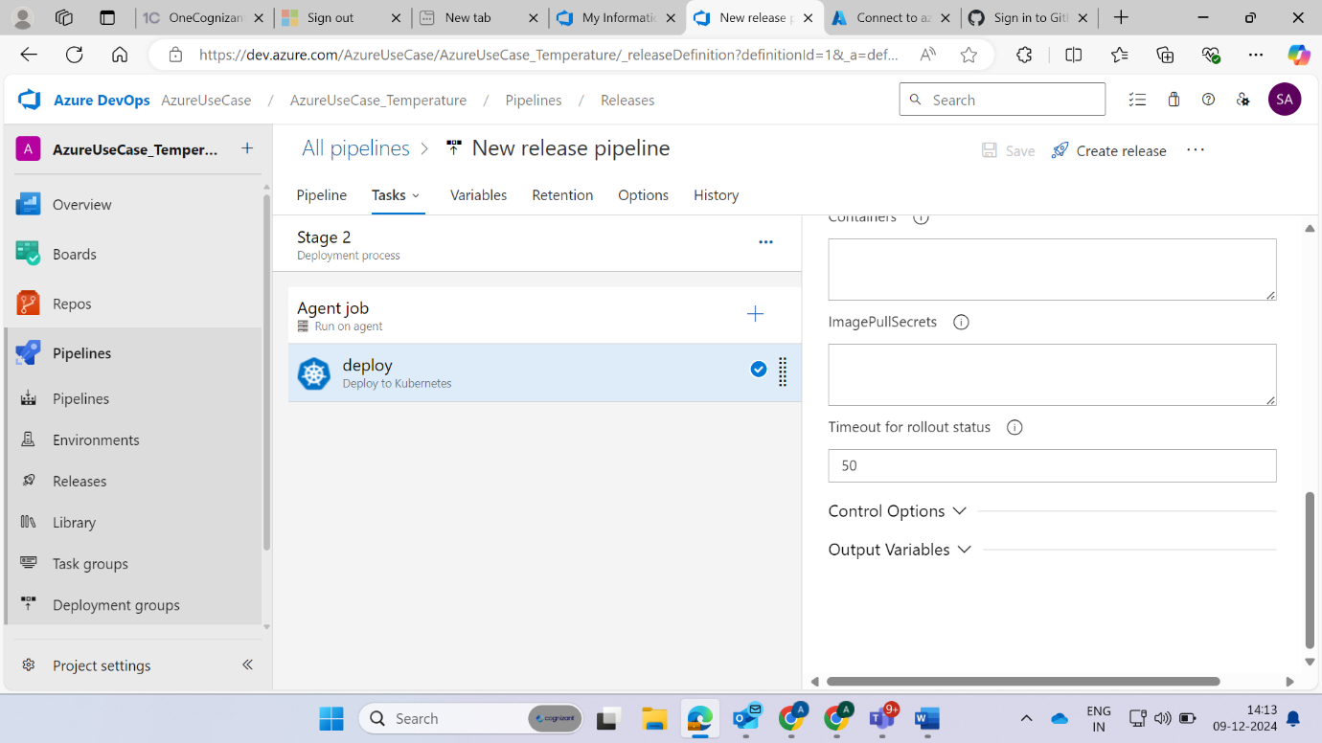

Similary again choose it and name it service

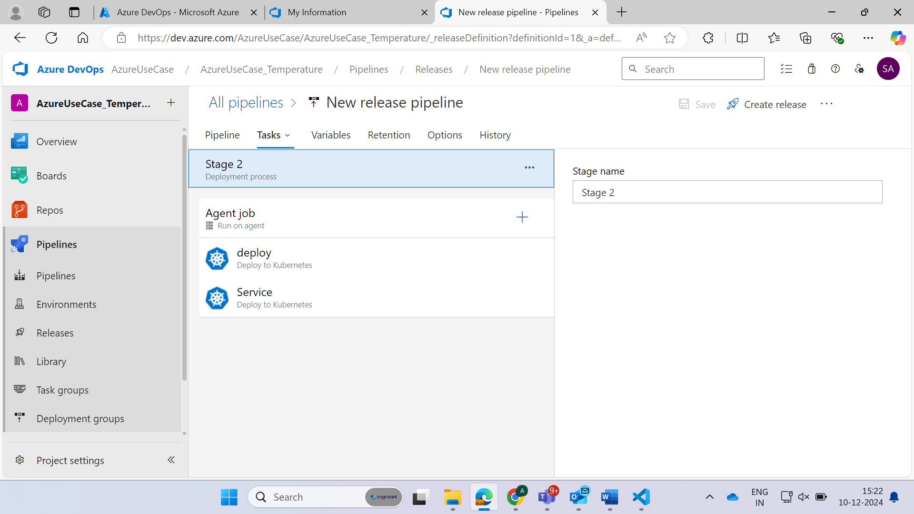

Click on create release option

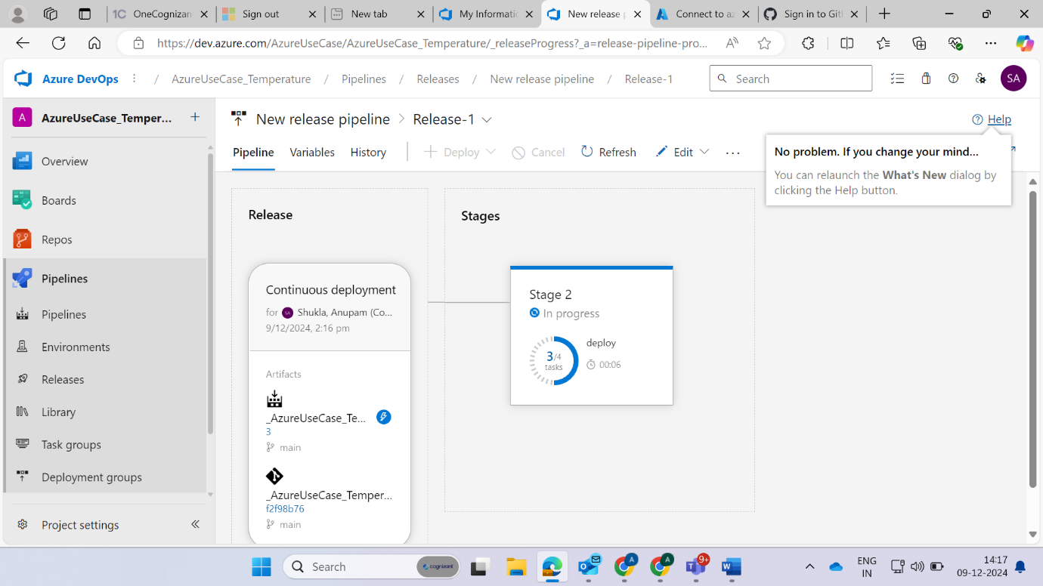

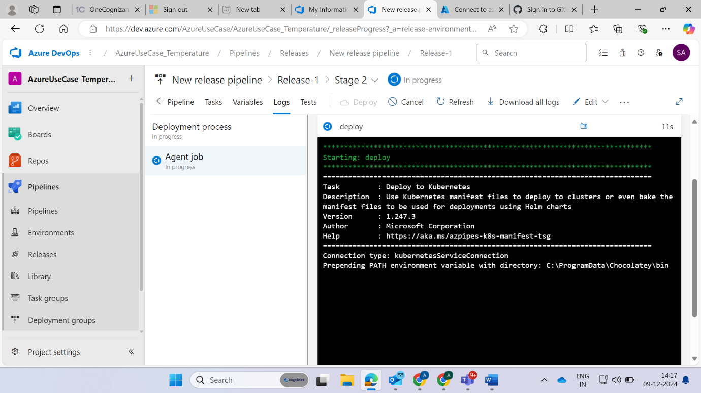

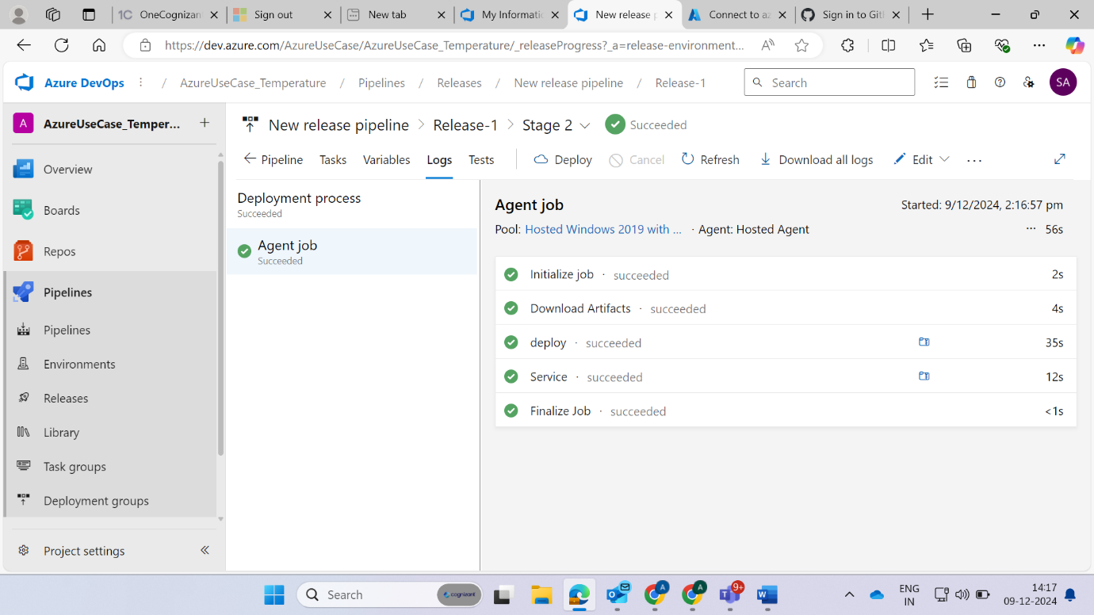



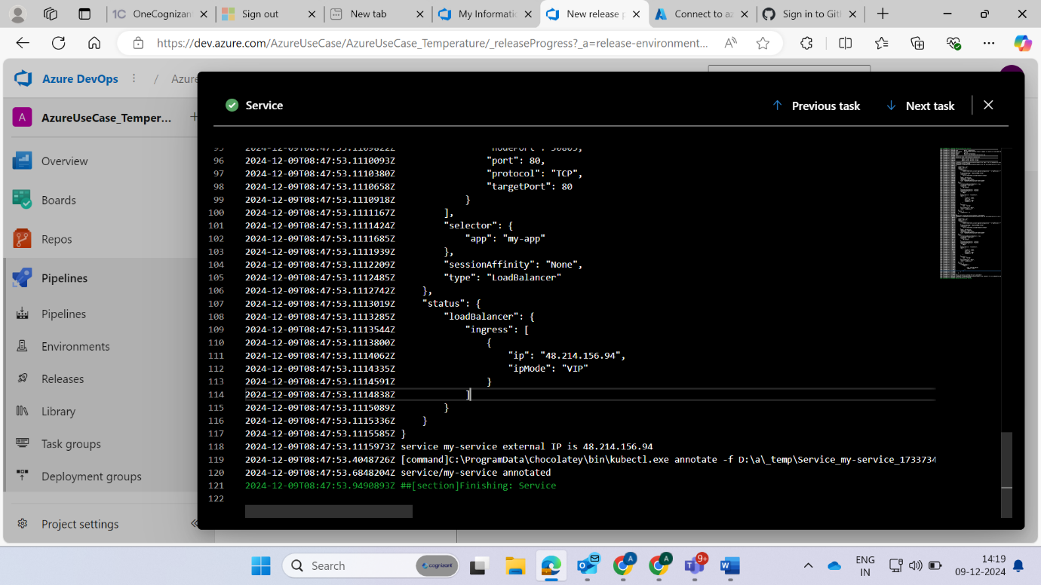

**Now by using external ip we can see our deployment**

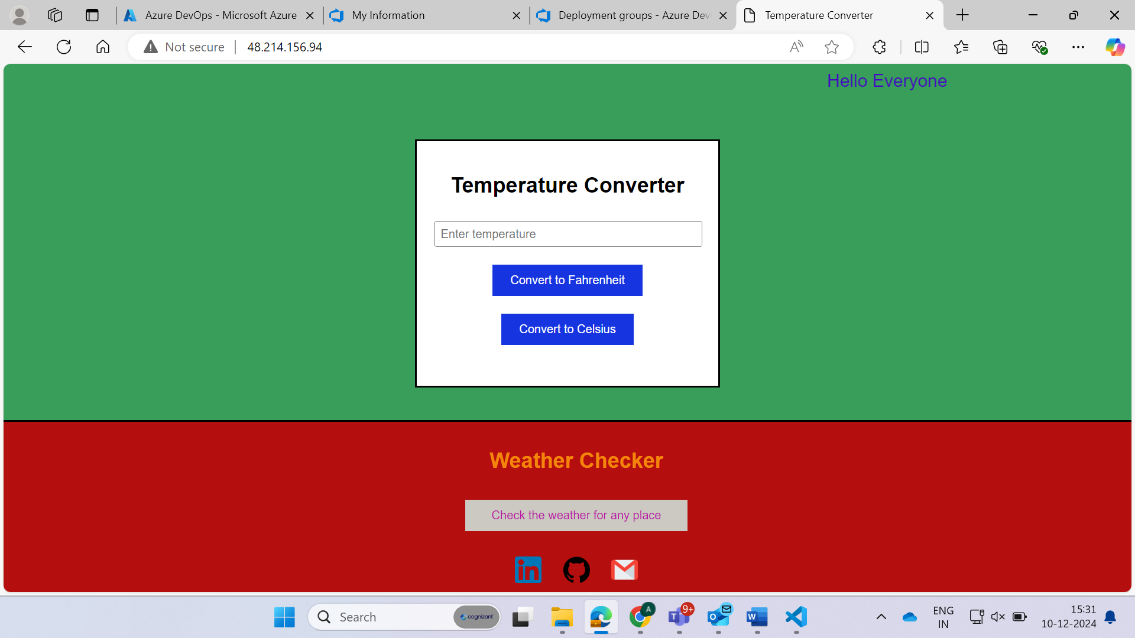

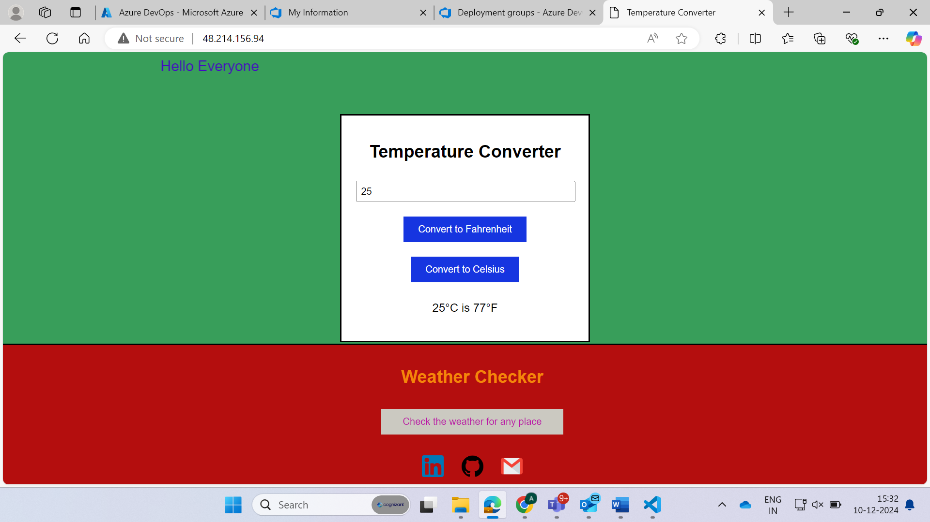

**When we click on weather app button then output**

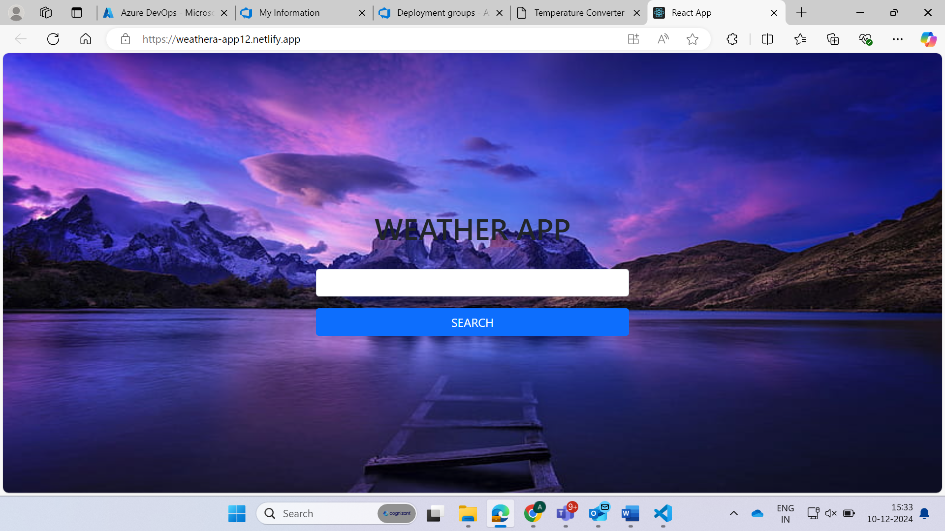

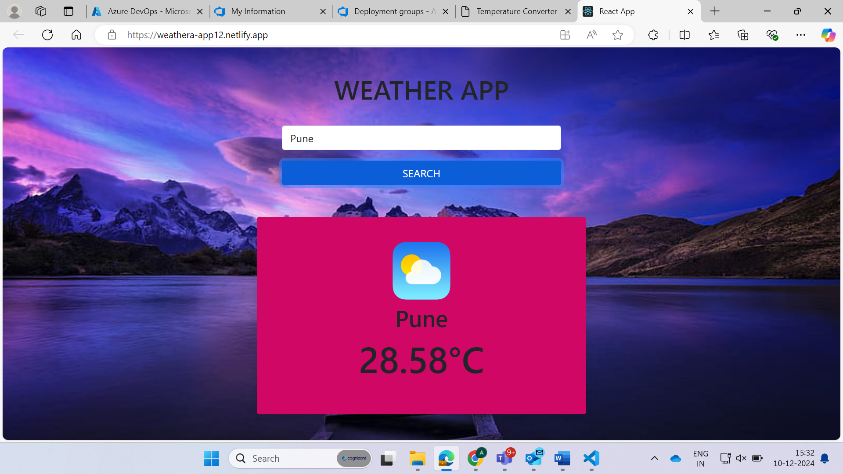

**When click on linkedin icon then linkedin will be opened**



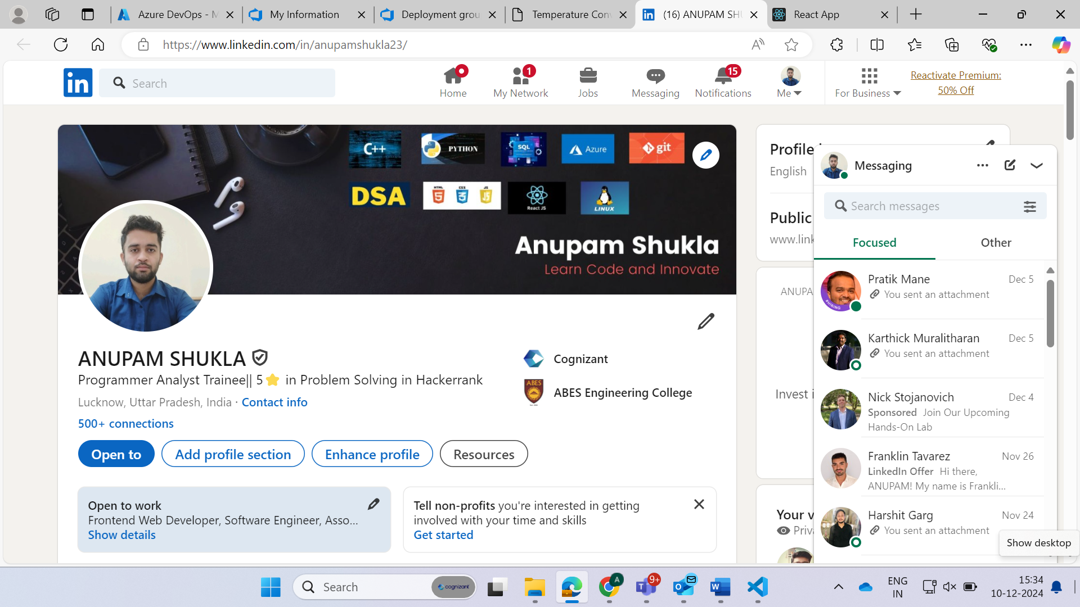

**When click on github icon then output**



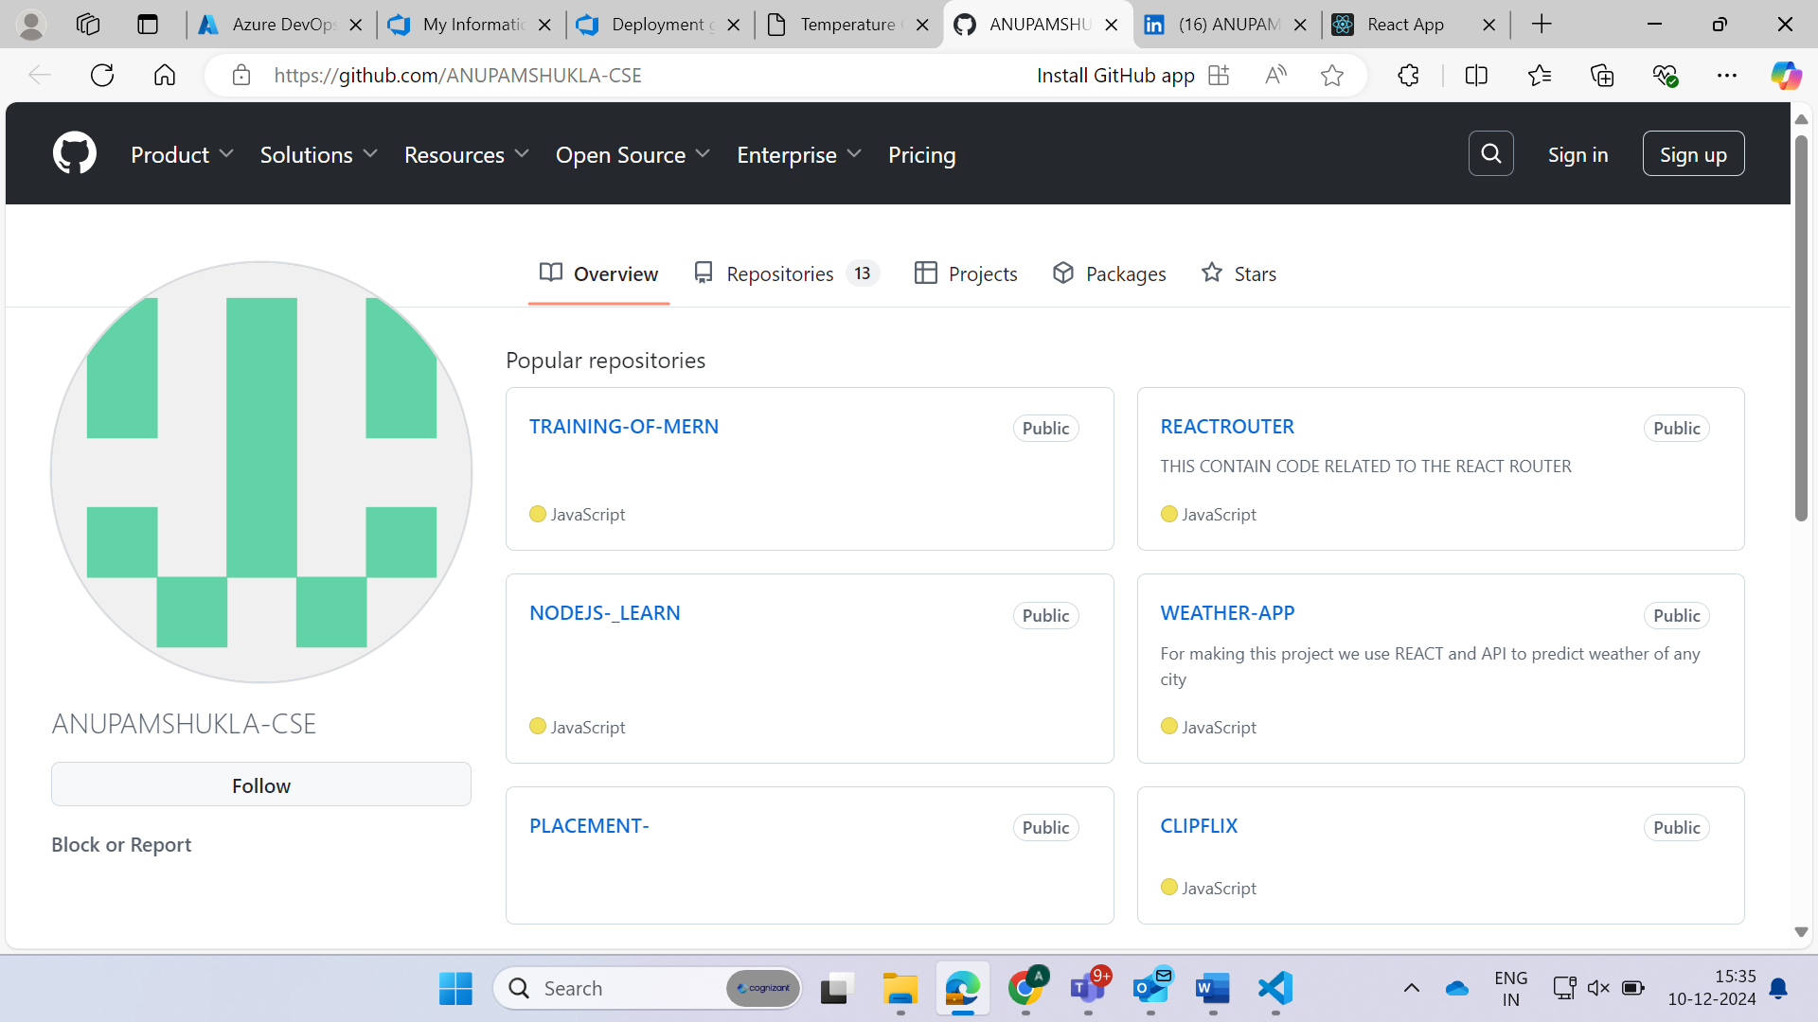

**When click on gmail icon then output**



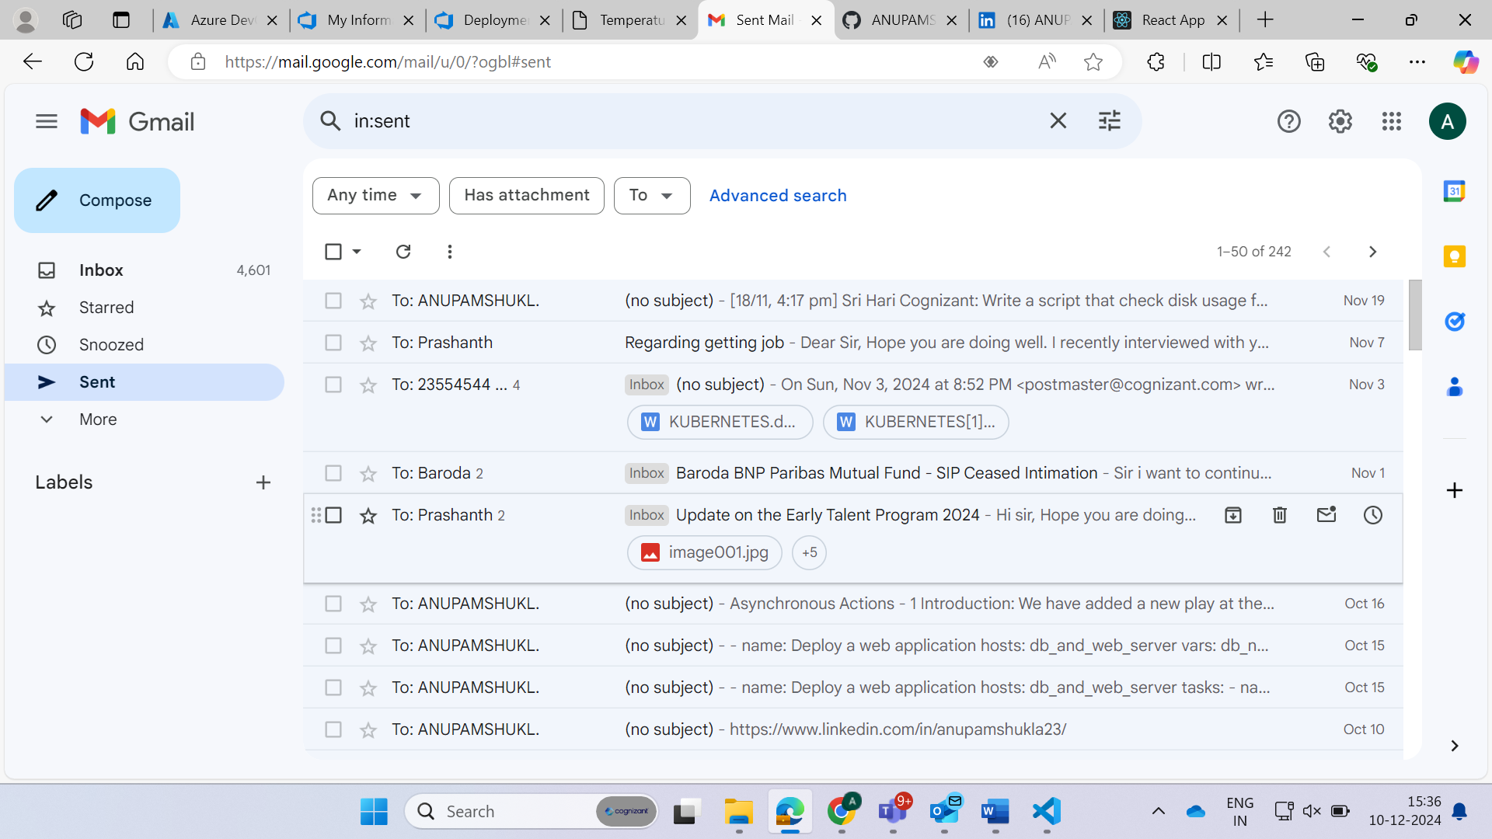

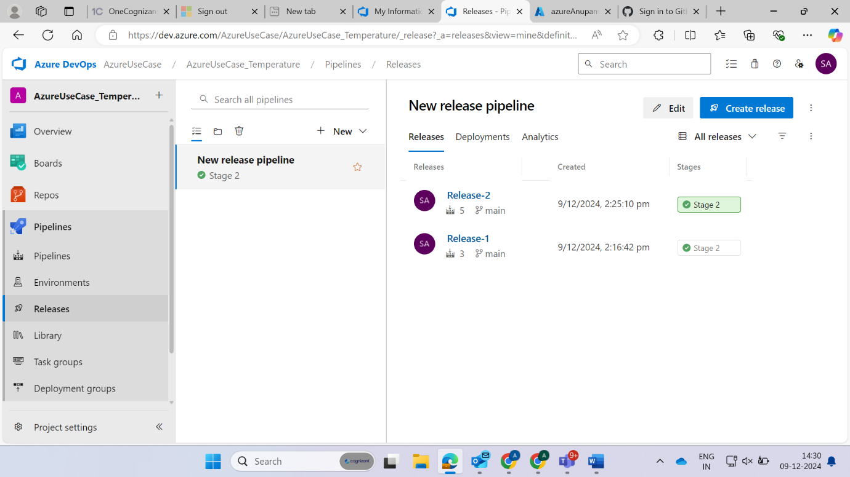

**Now if we want to do one more release click again on create release**

